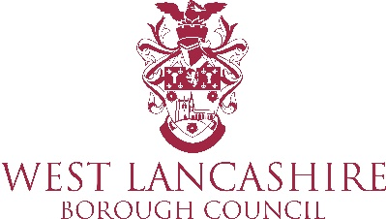

Community Engagement Briefing 11 January 2021

Reviewing the data from the previous week show that Covid19 cases across the borough, in all wards, are seeing an increase in cases. The areas most affected are:

Ashurst,

Knowsley

Skelmersdale South.

The highest cases are within the ages 25-44 followed by 45-54.

A Mobile Testing Unit will be available at the All Saints Church Hall Car Park in Hesketh Bank on 18 January. Residents can book an appointment if they are experiencing symptoms of Covid19 via www.gov.uk/get-coronavirus-test

Similar to other lockdowns the local paper (The Champion) will not be printed and distributed so we will continue to issue messages via the website and social media.
