
Tree Risk

Management Appraisal

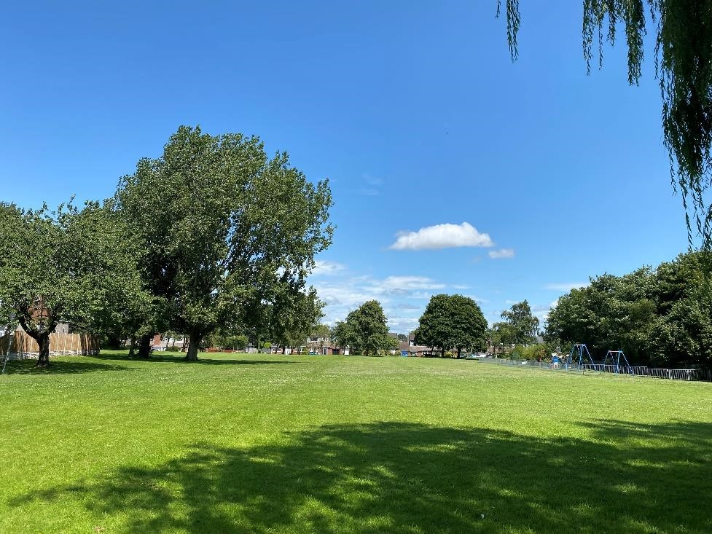

o
f
Trees
at

Six Sites under the Management of Aughton Parish Council, Aughton, Lancashire

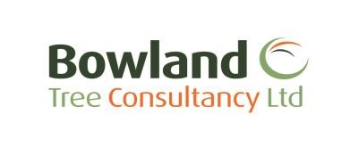
Pre
pa
red by:

July 2025

TREE RISK MANAGEMENT APPRAISAL
SIX SITES, AUGHTON PARISH COUNCIL, AUGHTON

CONTENTS

- CIVIL LAW REGARDING TREE OWNERSHIP AND DUTY OF CARE
- QTRA METHODOLOGY OVERVIEW AND APPLICATION IN MANAGEMENT DECISIONS
- PROTECTED SPECIES AND STATUTORY RESTRICTIONS
- SUMMARY OF SURVEY FINDINGS AND RECOMMENDATIONS
- GENERAL TREE MANAGEMENT COMMENTS
- TREE RISK MANAGEMENT STRATEGY RECOMMENDATIONS
- TREE SURVEY SCHEDULE
- TREE SURVEY PLAN
- QTRA PRACTICE NOTE



6 Cross Street  Preston  Lancashire  PR1 3LT | Ground Floor  14 Castlegate  Penrith  Cumbria CA11 7HZ
T: 01772 437150 | T: 01768 744450
E: info@bowlandtreeconsultancy.co.uk


TREE RISK MANAGEMENT APPRAISAL
SIX SITES, AUGHTON PARISH COUNCIL, AUGHTON

PROJECT DETAILS

Project No.: | BTC3156
Sites: | Granville Park War Memorial, L39 5DS  William Arnold Silcock Memorial Playing Field, L39 5DJ  Rachel Taylor Memorial Playing Field, L39 5DE  Redsands Park and Play area, L39 4SQ  The Common & The Precinct, L39 5DW  Delph Quarry Woodland, L39 5EB
Survey Type: | ‘Negative Recording’ Walkover Survey
Tree(s) Considered: Areas as identified by client

Report Time Frame: 12 months from date of issue

Next Inspection Date: ≈18 months from date of issue

Client: Aughton Parish Council

Survey Date: 03 July 2025

Surveyor: William Hawkswell ND Arb TechArborA

Report Prepared by: William Hawkswell ND Arb TechArborA

Report Checked by: Joseph Lambert BSc(Hons) FdSc MArborA MICFor

Date of Issue: 24 July 2025

Version No: 1

1. CIVIL LAW REGARDING TREE OWNERSHIP AND DUTY OF CARE

1.1 Under civil law the owner of the land on which a tree stands, together with any party who has control over the tree’s management, has a duty of care to take reasonable steps to prevent or minimise the risk of personal injury and/or damage to property from any tree located within the curtilage of the land in question.

1.2 In turn, it is accepted that these steps should normally include commissioning a qualified and experienced arboriculturist to survey the tree in order to identify and appraise any risk of harm to persons or damage to property that it may present and, where unacceptable risks are identified, taking suitable remedial action to negate or reduce those risks accordingly.

2. QTRA METHODOLOGY OVERVIEW AND APPLICATION IN MANAGEMENT DECISIONS

2.1 A survey was carried out in order to consider the general structural stability of the identified trees at the site and the associated risk of harm posed to persons and/or property and, from this information, to make management recommendations to reduce any risks identified to be unacceptable to a level that is considered to be either tolerable or broadly acceptable (see Table 1, below).

2.2 The Quantified Tree Risk Assessment (QTRA) methodology utilised for the tree survey (see appended QTRA Practice Note for more details) quantifies the three components of tree failure risk, which are:
i. Target (something with potential to be harmed and/or damaged by the mechanical failure of tree parts); ii. Impact Potential; and iii. Probability of Failure (within the coming year).

2.3 The product of the three component values is the annualised ‘Risk of Harm’, which is a combined measure of the likelihood and the consequence of tree failure considered in terms of the loss within the coming year, and is expressed as a probability. In applying the 'Tolerability of Risk Framework' (ToR) the QTRA methodology divides the ‘Risk of Harm’ into three threshold values, being;
- Unacceptable (i.e. >1/1,000), which is unacceptable and will not ordinarily be tolerated;
- Tolerable (i.e. between 1/1,000,000 and 1/1,000, where the Risk of Harm will be tolerable if it is As Low As Reasonably Practicable (ALARP); but a Risk of Harm 1/10,000 or greater will not ordinarily be Tolerable where it is imposed on others, such as the public. In the Tolerable range management decisions are informed by consideration of the benefits and costs of risk control, including benefits provided by trees that would be lost to risk control measures; and
- Broadly Acceptable (<1/1,000,000), which is already ALARP.

  - The QTRA advisory thresholds, (see Table 1, below) are proposed as a reasonable approach to balancing safety from falling trees with the costs of risk reduction. This approach takes account of the principles of ALARP and ToR, but does not dictate how these principles should be applied. While the thresholds can be the foundation of a robust policy for tree risk management, tree managers should make decisions based on their own situation, values and resources.

Table 1: QTRA Advisory Risk Thresholds:
Threshold | Description | Action
Risk of harm of  1/1,000 or greater | Unacceptable - Risks will not ordinarily be tolerated | ▪ Control the risk
Risk of harm between 1/1,000 and 1/10,000 | Unacceptable (where imposed on others) - Risks will not ordinarily be tolerated | - Control the risk  - Review the risk
Risk of harm between 1/1,000 and 1/10,000 | Tolerable (by agreement) Risks may be tolerated if those exposed to the risk accept it, or the tree has exceptional value | ▪ Control the risk unless there is broad stakeholder agreement to tolerate it, or the tree has exceptional value ▪ Review the risk
Risk of harm between 1/10,000 and 1/1,000,000 | Tolerable (where imposed on  others) - Risks are tolerable if  ALARP | - Assess costs and benefits of risk control  - Control the risk only where a significant benefit might be achieved at reasonable cost ▪ Review the risk
Risk of harm less than 1/1,000,000 | Broadly Acceptable - Risk is already ALARP | - No action currently required  - Review the risk

  - As detailed in Table 1, a Risk of Harm less than 1/1,000,000 is Broadly Acceptable and already ALARP
(i.e. ‘as low as reasonably practicable’). A Risk of Harm 1/1,000 or greater is unacceptable and will not ordinarily be tolerated. Between these two thresholds, the Risk of Harm is in the Tolerable region of the ToR Framework and will be tolerable if it is ALARP, but a Risk of Harm 1/10,000 or greater will not ordinarily be Tolerable where it is imposed on others, such as the public. Here, management decisions are informed by consideration of the benefits and costs of risk control, including benefits provided by trees that would be lost to risk control measures.

2.6 In respect of the above the assessor (i.e. Bowland Tree Consultancy Ltd) may consider the costs of risk control when providing options for management if specifically asked to do so, but the tree owner/manager, who owns the risk and therefore exercises control over the costs, must consider the balance and make the final management decision(s).

3. PROTECTED SPECIES AND STATUTORY RESTRICTIONS

Tree Preservation Orders and Conservation Area Designations

3.1 The Town & Country Planning Act (1990) (the Act) and associated Regulations empower Local Planning Authorities (LPAs) to protect trees in the interests of amenity by making Tree Preservation Orders (TPOs). The Act also affords protection for trees of over 75mm diameter that stand within the curtilage of a Conservation Area (CA). Subject to certain exemptions, an application must be made to the LPA in question to carry out works upon or to remove trees that are subject to a TPO, whilst six weeks’ notice of intention must be given to carry out works upon or to remove trees within a CA that are not protected by a TPO.

3.2 According to the LPA’s website, checked 10 July 2025, the site at Granville Park stands within a Conservation Area. According to the LPA map on their website, no other sites are located within a CA. We were unable to check for TPO’s; however, the client’s representative did inform us that the woodland at Delph Quarry is covered by a TPO. As such, it is essential that the presence of any further statutory tree protection at the sites be checked directly with West Lancashire Borough Council, and any relevant permissions are obtained from the planning department of the local council, prior to scheduling or undertaking any tree works.

Protected Species

3.3 Nesting birds are afforded statutory protection under the Wildlife & Countryside Act (1981) (as amended) and their potential presence should therefore be considered when clipping hedges, removing climbing plants and pruning and removing trees. The breeding period for woodlands runs from March to August inclusive. Hedges provide valuable nesting sites for many birds and clipping should therefore be avoided during March to July. Trees, hedges, and ivy should be inspected for nests prior to pruning or removal and any work likely to destroy or disturb active nests should be avoided until the young have fledged.

3.4 All bat species and their roosts are protected under Schedule 5 of the Wildlife & Countryside Act (1981) (as amended) and under Schedule 2 of the Conservation of Habitats and Species Regulations 2017 (as amended). In this respect, it should be noted that it is possible that unidentified bat habitat features may be located high in tree crowns and all personnel carrying out tree works at the site should therefore be vigilant and mindful of the possibility that roosting bats may be present in trees with such features. If any bat roosts are identified, then it is essential that works are halted immediately and that a suitably qualified and experienced ecologist investigates and advises on appropriate actions prior to works continuing.

3.5 In turn, any subsequent works carried out in relation to any protected species must be carried out under guidance from a suitably qualified and experienced ecologist and in strict accordance with applicable industry guidance (i.e. BS8596:2015 - Surveying for Bats in Trees and Woodlands).

Felling Licences

3.6 Subject to certain exemptions the Forestry Act (1967) requires that a ‘Felling Licence’ be obtained to remove growing trees amounting to more than five cubic metres of timber in a calendar quarter, providing no more than two cubic metres are sold. Felling Licences are administered by the Forestry Commission and contravention of the associated controls can incur substantial penalties. A felling licence is, however, not required for trees standing within the curtilage of a private residential garden, orchard, churchyard or in public open spaces such as land registered under the Commons Act 1899, village greens, public parks and public gardens.

4. SUMMARY OF SURVEY FINDINGS AND RECOMMENDATIONS

4.1 A negative recording’ ‘Walkover Tree Survey’ (see ‘Schedule of Operations’ appended to agreed project quote) was undertaken on 03 July 2025 at six sites identified by the client Aughton Parish Council.

4.2 As a negative recording survey, only trees identified to have observable structural defects and a subsequent ‘Risk of Harm’ that falls within the ‘Broadly Acceptable’ to ‘Unacceptable range were recorded (see ‘Schedule of Operations’ appended to agreed project quote for more details in this respect). Other trees requiring general management works and/or specific features to be monitored were also recorded at the discretion of the surveyor.

4.3 The survey identified 30 individual trees, five groups of trees and one woodland. They are in the young to mature age range and have heights of up to approximately 32 metres, stem diameters of up to 1280 millimetres, and maximum diametral crown spreads of up to approximately 20 metres.

4.4 The sites under consideration consisted of four public parks, a war memorial site and public woodland area located on a historic quarry site, all located north-east of the village of Aughton. Excluding the woodland area, the remaining sites exhibited formal management of vegetation and public amenities as well as constructed hard standing public footpaths.

4.5 In regards to the woodland area, the footpaths are comprised of compacted soil, subsequent of foot traffic throughout the site. The woodland evidently has fluctuating occupancy levels, with highest occupancy area located around the central clearing of the site, we were also informed by the clients representative that that woodland site is under high usage from children on bikes, and as identified by the surveyor on site, the place with the highest occupancy bike trails and features is in the the aforementioned clearing in the middle of the woodland.

4.6 As a component of this appraisal various targets were identified to be within falling distances of the surveyed trees, including, but not restricted to, pedestrians using the various public rights of way, moving vehicles and their occupants using public highways, and various items of property including buildings, parked vehicles, overhead cables and boundary features such as fences and walls.

4.7 Furthermore, a widespread presence of Ash Dieback Disease (Hymenoscyphus fraxineus) was noted throughout the Ash tree population, both within the sites under consideration and the wider local landscape. Consequently, Ash trees exhibiting substantial decline as a result of the disease, and within falling distances of identifiable targets under obvious moderate to high usage were recorded as a component of the survey.

4.8 In turn, as a guide, the surveyed Ash trees have been assessed in accordance with the following scales of approximate percentages of remaining canopy at the time of viewing:

- Class 1 – 100% canopy - Healthy trees displaying good vitality;
- Class 2 – 75% canopy - Weakened trees show treetop shoots in the degeneration phase;
- Class 3 – 50% canopy – Severely weakened trees exhibiting a significant reduction in vitality, e.g. with bushy and lumpy accumulation of growth; and
- Class 4 – 25% canopy – Trees in a state of severe decline, e.g. with large dead canopy areas and twigs and branches starting to break off.

  - With regard to these classifications, it is emphasised that trees falling within Class 3 - 4 are normally recommended for risk management remedial works where there are targets exist within falling distance of said trees.

  - In turn, as highlighted with the colours orange, yellow and green in the appended Tree Survey Schedule and in Table 2 (on the subsequent page), the risk assessment established that all the surveyed tree have calculated QTRA risk indices that fall within the acceptable to unacceptable risk threshold range of less than 1/4,000 to less than 1,000,000 (please refer to Table 1, on page 1, with regard to advisory tree risk thresholds). As highlighted in the colour orange, trees T6 and T27 have risk indicis that fall in the unacceptable risk threshold of less than 1/10,000. As such, remedial works are recommended to negate the risk.

Table 2: Summary of Tree Risk Categorisation (see TSS for Remedial Work Recommendations):
Risk Rating | Tree/Group/Woodland Number
Unacceptable | -
Unacceptable | T6, T27.
Tolerable | T1, T2, T3, T5, T11, T12, T13, T16, T18, T23, T24, T25, T30, G03, G06.
Broadly  Acceptable | T4, T7, T8, T9, T10, T14, T15, T17, T19, T20, T21, T22, T26, T28, T29, G01, G02, G04, G05, W1.
*Note: it shall be the client’s responsibility to arrange contact with the applicable council’s planning department to check for any statutory tree protection, and obtain any necessary permissions if required, prior to scheduling or carrying out any tree works

5. GENERAL TREE MANAGEMENT COMMENTS

5.1 During the course of the survey, it was noted that the canopies of a number of the trees border multiple high usage roads, access driveways and associated footways. In this respect it is generally accepted that the minimum clearances should be approximately 2.5 metres over a footpath and 5.05 metres over a road carriageway which, in turn, should give sufficient clearance for a person with a raised umbrella to walk unimpeded along a footpath and for a double-decker bus to travel along a road without striking any overhanging branches. Furthermore, adequate clearance should be maintained to visibility splays from junctions and accesses and also to road signs and street lights.

6. TREE RISK MANAGEMENT STRATEGY RECOMMENDATIONS

6.1 In consideration of the high usage of various areas of the wider site, and the proximity of the trees to various items of property, and the associated identified targets such as parked and moving vehicles and pedestrians and residential properties and parked cars, it is subsequently recommended that all of the trees be re-inspected on a cyclical programme of roughly every 18 months, so that they can be alternately viewed whilst both in and out of leaf in order to monitor both their structural and physiological condition and, consequently, for the site occupiers to meet their duty of care. In this respect it is therefore recommended that the trees be re-inspected during winter 2026/27.

6.2 Additionally, it is strongly recommended that the client undertakes a walkover check of trees around the site following any inclement weather events, and observes the trees during their day to day activities and routines. This is recommended to identify any obvious risk features, such as broken, split or hanging branches, root-plate heave, the apparition of fungal fruiting bodies etc. that could have occurred following inclement weather, and, if subsequently identified as necessary, to then seek appropriate advice from a tree contractor or tree consultant.

  Site: | Granville Park War Memorial, Aughton, Lancashire, L39 5DJ
  Client: | Aughton Parish Council
  Brief: | Carry out a ‘Negative Recording’ Walkover Survey within area specified by client, report on projected risk posed to persons and property, and make management recommendations where appropriate
  Surveyor: | William Hawkswell ND Arb |  | Page: 1 of 13
  Survey Date: | 03 July 2025 |  | Page: 1 of 13
  Viewing Conditions: | Bright, no discernible wind |  | Page: 1 of 13
  Job Reference: | BTC3156 |  | Page: 1 of 13

No. | Species | Age | Height (m) | Stem Diam. (mm) | Crown  Spread  (m) | Vital- ity | Comments | Management Recommendations | Risk Assessment  Description  (Part/Target) | Target | Size | P.O.F | Reduced Mass % | Risk Index | Work  Priority

 | T1 | Common Ash | M |  | 17 | 540 | 12 | G | - Early displacement of public footpath hardstanding subsequent of incremental surface root growth.  - Stem bifurcates at a height of 4m.  - Previous crown lift pruning to a height of approximately 7m.  - Signs indicative of an early stage of decline subsequent of colonisation by Ash Dieback Disease (ADD) with remaining canopy falling into Class 1/2 (see para. 4.7 of report).  - Crown biased over neighbouring Co-op car park.  - Moderate instances of deadwood to a diameter of approximately 70mm.  - Minor thinning of canopy. | ▪ Tree consultant to monitor tree’s structural and physiological condition annually due to evident colonisation of ADD. | P = Deadwood to 70mm diameter.  T = Persons using public footpath  running adjacent to the memorial park. | 2 | 4 | 3 | 50% | 1M | L
 | T2 | Common Ash | M |  | 19 | 590 | 11 | M | - Cavity at a height of 3m, to a diameter of approximately 230mm, subsequent of previous crown pruning works.  - Stem bifurcates at a height of 8m.  - Previous crown lift pruning to a height of approximately 10m.  - Signs indicative of an early stage of decline subsequent of colonisation by ADD with remaining canopy falling into Class 1 (see para. 4.7 of report). | ▪ Tree consultant to monitor tree’s structural and physiological condition annually due to evident colonisation of ADD. | P = Deadwood to 70mm diameter.  T = Persons using public footpath  running adjacent to the memorial park. | 2 | 4 | 3 | 50% | 1M | L
 | T3 | Common Ash | EM |  | 15 | 330 | 9 | M | - Previously crown lifted to a height of approximately 7m.  - Canopy suppressed and biased south towards war memorial.  - Moderately minor deadwood over memorial up to 50mm diameter.  - Signs indicative of an early stage of decline subsequent of colonisation by ADD with remaining canopy falling into Class 1 (see para. 4.7 of report). | ▪ Tree consultant to monitor tree’s structural and physiological condition annually due to evident colonisation of ADD. | P = Deadwood to 50mm diameter.  T = Persons visiting the war memorial. | 2 | 4 | 3 | 50% | 1M | L
HEADINGS & ABBREVIATIONS  NO.  SPECIES:  AGE:  HEIGHT:  DIAMETER:  CROWN SPREAD:  VITALITY:  MANAGEMENT:  TARGET RANGE:  RISK ASSESSMENT DESCRIPTION:  SIZE RANGE: P.O.F:  REDUCED MASS %: |  |  |  | TREE/GROUP REFERENCE NUMBER. REFER TO PLAN OR NUMBERED TAGS WHERE APPLICABLE COMMON NAME  Y = YOUNG, SM = SEMI MATURE, EM = EARLY MATURE, M = MATURE, PM = POST MATURE  APPROXIMATELY 80% OF TREES ARE MEASURED USING AN ELECTRONIC CLINOMETER AND THE REMAINDER ESTIMATED AGAINST THE MEASURED TREES STEM DIAMETER MEASURED OR ESTIMATED AT A HEIGHT OF APPROXIMATELY 1.3 METRES  MEASURED OR ESTIMATED DIAMETER OF CROWN(S) AT THE WIDEST POINT  A MEASURE OF PHYSIOLOGICAL CONDITION WHEREBY D = DEAD, MD = MORIBUND, P = POOR, M = MODERATE, G = GOOD  SUFFIXES: (M) = FOR GENERAL ARBORICULTURAL OR SILVICULTURAL MANAGEMENT; (S) = TO REMOVE OR REDUCE THE RISK OF DIRECT DAMAGE TO A FIXED STRUCTURE BY MEANS OF CIRCUMFERENTIAL ROOT, STEM OR BRANCH GROWTH; (I) = TO ENABLE THE TREE(S) TO BE INSPECTED  FURTHER FOR RISK ASSESSMENT PURPOSES  HIGHEST VALUE TARGET THAT THE MOST SIGNIFICANT PART LIKELY TO FAIL COULD STRIKE. RANGES 1-6. 1 = HIGH, 6 = LOW VALUE/OCCUPANCY  DESCRIPTION OF PART IDENTIFIED AS MOST LIKELY TO FAIL AND ASSOCIATED TARGET, ASSESSED IN ACCORDANCE WITH QTRA SYSTEM  SIZE CATEGORY OF MOST SIGNIFICANT PART CONSIDERED LIKELY TO FAIL. - RANGES 1-4 WHEREBY 1 = LARGE, 4 = SMALL, P = PROPERTY PROBABILITY OF FAILURE WITHIN 12 MONTHS. RANGES 1-7. 1 = HIGH, 7 = LOW  WHERE THE MASS OF A TREE OR BRANCH IS REDUCED BY DEGRADATION THE RISK INDEX IS MULTIPLIED TO REFLECT THE PERCENTAGE OF MASS REDUCTION

RISK INDEX: E.G. RISK INDEX 20 = RISK OF SIGNIFICANT HARM 1 IN 20,000. AN ADDITIONAL FIGURE, IN BRACKETS, MAY BE SUFFIXED ‘T’ REPRESENTING THE RATE OF MULTIPLE OCCUPATION OVER THE YEAR, E.G. 10(10T) REPRESENTS A RISK OF HARM 1/10,000 TO 10 OCCUPANTS OR AN EQUIVALENT MONETARY VALUE. SEE QTRA PRACTICE NOTE FOR MORE INFORMATION REGARDING COLOURS USED TO SIGNIFY RISK INDEX

WORK PRIORITY: H (HIGH) = TREE WORKS TO BE GIVEN IMMEDIATE CONSIDERATION. M (MODERATE) = TREE WORKS TO BE CARRIED OUT WITHIN 12 MONTHS OF SURVEY (TIMING MAY BE SPECIFIED IN MANAGEMENT RECOMMENDATIONS). L (LOW) = TREE WORKS THAT ARE NOT
CONSIDERED ESSENTIAL FOR RISK MANAGEMENT PURPOSES, BUT ARE RECOMMENDED IN ACCORDANCE WITH PRUDENT ARBORICULTURAL MANAGEMENT (TO BE REVIEWED IN 12 MONTHS, OR SPECIFIED TIME, IF APPLICABLE). N/A = NOT APPLICABLE

Site: | Granville Park War Memorial, Aughton, Lancashire, L39 5DJ |  | Surveyor: | William Hawkswell ND Arb |  | Page: 2 of 13
Client: | Aughton Parish Council |  | Survey Date: | 03 July 2025 |  | Page: 2 of 13
Brief: | Carry out a ‘Negative Recording’ Walkover Survey within area specified by client, report on projected risk posed to persons and property, and make management recommendations where appropriate |  | Viewing Conditions: | Bright, no discernible wind |  | Page: 2 of 13
Brief: |  |  | Job Reference: | BTC3156 |  | Page: 2 of 13

No. | Species | Age | Height (m) | Stem Diam. (mm) | Crown  Spread  (m) | Vital- ity | Comments | Management Recommendations | Risk Assessment  Description  (Part/Target) | Target | Size | P.O.F | Reduced Mass % | Risk Index | Work  Priority

T4 | Boxelder Maple | EM | 15 | 1x500  1x220  (ts) | 16 | G | - Branches beginning to encroach war memorial to the north of the tree.  - Branches encroach public highway to the south of the tree by approximately 1.5m.  - Southern canopy bias over highway and associated footpath.  - Moderate deadwood up to approximately 25mm diameter throughout canopy, typical of species. | ▪ Tree contractor to prune tree canopy by up to approximately 2m to attain approximately 4m clearance to highway to south and 1m clearance from memorial to north. | P = Deadwood up to 25mm diameter.  T = Persons visiting the war memorial. | 2 | 4 | 3 | 25% | <1M | M

Site: | William Arnold Silcock Memorial Playing Field, Aughton, Lancashire, L39 5DJ |  | Surveyor: | William Hawkswell ND Arb
Client: | Aughton Parish Council |  | Survey Date: | 03 July 2025
Brief: | Carry out a ‘Negative Recording’ Walkover Survey within area specified by client, report on projected risk posed to persons and property, and make management recommendations where appropriate |  | Viewing Conditions: | Bright, no discernible wind
Brief: |  |  | Job Reference: | BTC3156

No. | Species | Age | Height (m) | Stem Diam. (mm) | Crown  Spread  (m) | Vital- ity | Comments | Management Recommendations | Risk Assessment  Description  (Part/Target) | Target | Size | P.O.F | Reduced Mass % | Risk Index | Work  Priority
Page: 3 of 13

 | T05 | Sargent Cherry | EM |  | 12 | 420 | 9 | P | - Exposed surface roots.  - Moderate south east stem lean.  - Multi stemmed from 2.2m height.  - 500mm x 500mm wound to south west of tree at 2.2m where main stem trifurcates with exposed brown rot decay exposed, minor occluding wood present.  - Moderate amount of deadwood up to approximately 75mm diameter throughout canopy.  - Moderately severe thinning of canopy. | ▪ Tree contractor to remove tree due to identified increased risk of failure and subsequent risk of harm to persons. | P = Deadwood up to 75mm diameter.  T = Persons using and accessing  children's play part to north east of tree. | 2 | 4 | 2 | N/A | 100 K | M
 | T06 | Norway Maple | EM |  | 16 | 490 | 10 | P | - Large longitudinal split arising from main stem union at  2.2m down to 1m above ground.  - South east stem is partially hung up in neighbouring tree hanging over a wooded area in the park. | ▪ Tree contractor to remove tree due to identified increased risk of failure and unacceptable risk of harm to persons. | P = Stems at main union,  approximately  260mm diameter.  T = Persons using park. | 3 | 3 | 1 | N/A | 10K | H
 | T07 | Silver Birch | SM |  | 13 | 260 | 6 | G | - Epicormic growth restricting access to the base of the tree and therefore not viewed or inspected in detail.  - Numerous poo bags deposited in epicormic growth. | ▪ Tree contractor to remove epicormic growth from around the base of the tree to facilitate future inspections (I). | P = Deadwood up to 25mm diameter.  T = Persons using park. | 3 | 4 | 3 | 25% | <1M | M
 | T08 | Lombardy Poplar | SM |  | 25 | 640 | 12 | G | - Epicormic growth restricting access to the base of the tree and therefore not viewed or inspected in detail.  - Numerous dog poo bags deposited in epicormic growth. | ▪ Tree contractor to remove epicormic growth from around the base of the tree to facilitate future inspections (I). | P = Deadwood up to 25mm diameter.  T = Persons using park. | 3 | 4 | 3 | 25% | <1M | M
HEADINGS & ABBREVIATIONS  NO.  SPECIES:  AGE:  HEIGHT:  DIAMETER:  CROWN SPREAD:  VITALITY:  MANAGEMENT:  TARGET RANGE:  RISK ASSESSMENT DESCRIPTION:  SIZE RANGE: P.O.F:  REDUCED MASS %: |  |  |  | TREE/GROUP REFERENCE NUMBER. REFER TO PLAN OR NUMBERED TAGS WHERE APPLICABLE COMMON NAME  Y = YOUNG, SM = SEMI MATURE, EM = EARLY MATURE, M = MATURE, PM = POST MATURE  APPROXIMATELY 80% OF TREES ARE MEASURED USING AN ELECTRONIC CLINOMETER AND THE REMAINDER ESTIMATED AGAINST THE MEASURED TREES STEM DIAMETER MEASURED OR ESTIMATED AT A HEIGHT OF APPROXIMATELY 1.3 METRES  MEASURED OR ESTIMATED DIAMETER OF CROWN(S) AT THE WIDEST POINT  A MEASURE OF PHYSIOLOGICAL CONDITION WHEREBY D = DEAD, MD = MORIBUND, P = POOR, M = MODERATE, G = GOOD  SUFFIXES: (M) = FOR GENERAL ARBORICULTURAL OR SILVICULTURAL MANAGEMENT; (S) = TO REMOVE OR REDUCE THE RISK OF DIRECT DAMAGE TO A FIXED STRUCTURE BY MEANS OF CIRCUMFERENTIAL ROOT, STEM OR BRANCH GROWTH; (I) = TO ENABLE THE TREE(S) TO BE INSPECTED  FURTHER FOR RISK ASSESSMENT PURPOSES  HIGHEST VALUE TARGET THAT THE MOST SIGNIFICANT PART LIKELY TO FAIL COULD STRIKE. RANGES 1-6. 1 = HIGH, 6 = LOW VALUE/OCCUPANCY  DESCRIPTION OF PART IDENTIFIED AS MOST LIKELY TO FAIL AND ASSOCIATED TARGET, ASSESSED IN ACCORDANCE WITH QTRA SYSTEM  SIZE CATEGORY OF MOST SIGNIFICANT PART CONSIDERED LIKELY TO FAIL. - RANGES 1-4 WHEREBY 1 = LARGE, 4 = SMALL, P = PROPERTY PROBABILITY OF FAILURE WITHIN 12 MONTHS. RANGES 1-7. 1 = HIGH, 7 = LOW  WHERE THE MASS OF A TREE OR BRANCH IS REDUCED BY DEGRADATION THE RISK INDEX IS MULTIPLIED TO REFLECT THE PERCENTAGE OF MASS REDUCTION
RISK INDEX: E.G. RISK INDEX 20 = RISK OF SIGNIFICANT HARM 1 IN 20,000. AN ADDITIONAL FIGURE, IN BRACKETS, MAY BE SUFFIXED ‘T’ REPRESENTING THE RATE OF MULTIPLE OCCUPATION OVER THE YEAR, E.G. 10(10T) REPRESENTS A RISK OF HARM 1/10,000 TO 10 OCCUPANTS OR AN EQUIVALENT MONETARY VALUE. SEE QTRA PRACTICE NOTE FOR MORE INFORMATION REGARDING COLOURS USED TO SIGNIFY RISK INDEX

WORK PRIORITY: H (HIGH) = TREE WORKS TO BE GIVEN IMMEDIATE CONSIDERATION. M (MODERATE) = TREE WORKS TO BE CARRIED OUT WITHIN 12 MONTHS OF SURVEY (TIMING MAY BE SPECIFIED IN MANAGEMENT RECOMMENDATIONS). L (LOW) = TREE WORKS THAT ARE NOT
CONSIDERED ESSENTIAL FOR RISK MANAGEMENT PURPOSES, BUT ARE RECOMMENDED IN ACCORDANCE WITH PRUDENT ARBORICULTURAL MANAGEMENT (TO BE REVIEWED IN 12 MONTHS, OR SPECIFIED TIME, IF APPLICABLE). N/A = NOT APPLICABLE

T09 | Field Maple | SM | 13 | 330 | 8 | G | - Epicormic growth restricting access to the base of the tree and therefore not viewed or inspected in detail.  - Numerous poo bags deposited in epicormic growth. | ▪ Tree contractor to remove epicormic  growth from around base of tree to facilitate future inspections (I). | P = Deadwood up to 25mm diameter.  T = Persons using park. | 3 | 4 | 3 | 25% | <1M | M
T10 | Common  Alder | SM | 13 | 340 | 8 | G | - Epicormic growth restricting access to the base of the tree and therefore not viewed or inspected in detail.  - Numerous poo bags deposited in epicormic growth. | ▪ Tree contractor to remove epicormic  growth from around base of tree to facilitate future inspections (I). | P = Deadwood up to 25mm diameter.  T = Persons using park. | 3 | 4 | 3 | 25% | <1M | M
T11 | Norway Maple | EM | 13 | 410 | 8 | P | - Approximately 30% dieback in canopy, indicating an evident reduction in both vigour and vitality.  - Dead branches up to approximately 260mm arise from main stem union at 2.2m height. | ▪ Tree contractor to remove tree due to evident progressive decline and subsequent identified increased risk of failure and harm to persons. | P = Branches up to approximately  260mm diameter.  T = Persons using park. | 3 | 2 | 3 | N/A | 100 K | M
T12 | Common  Alder | SM | 10 | 290 | 6 | P | - Epicormic growth restricting access to the base of the tree and therefore not accessed to view or inspected in detail.  - Brown rot decay evident at base of stem evidently caused by strimmer damage, showing a minor amount of occluding wood.  - Approximately 20-30% dieback of canopy indicating a evident reduction in vitality.  - Moderate deadwood up to approximately 50mm diameter. | ▪ Tree contractor to remove tree due to evident progressive decline and subsequent identified increased risk of failure and harm to persons. | P = Whole tree at ground level.  T = Persons using park. | 3 | 2 | 3 | N/A | 100 K | M
T13 | Common Oak | M | 21 | 580 | 13 | M | - Small areas of flaking bark around the circumference of the main stem with exposed dried sapwood.  - Eastern canopy bias with two large diameter branches up to approximately 240mm diameter with longitudinal splits up to approximately 2m in length.  - Branches to the south of the canopy have historically been reduced leaving a hole in the canopy with areas of dense epicormic growth. | ▪ Tree contractor to prune tree to reduce whole canopy by up to approximately 2-3m to reduce loading on the branch unions and to reduce the risk of potential future branch failures, as has occurred historically. | P = Split branches up to  approximately  240mm diameter.  T = Persons using park. | 3 | 3 | 3 | N/A | 500 K | M

T14 | Common  Horse  Chestnut | SM | 13 | 450 | 9 | M | - Spiralling longitudinal crack up the main stem from 1m,  3m in length spiralling around main stem bifurcation at 2m height, up to approximately 120mm width, with exposed soft rot decay within.  - Moderate amount of deadwood throughout canopy up to approximately 100mm diameter. | ▪ Tree consultant to monitor structural and physiological condition of tree annually as part of cyclical inspection programme. | P = Deadwood up to approximately  100mm diameter.  T = Persons using park. | 3 | 4 | 3 | 25% | <1M | L
T15 | Common Ash | EM | 21 | 420 | 14 | M | - Signs indicative of an early stage of decline subsequent of colonisation by ADD with remaining canopy falling into Class 1/2 (see para. 4.7 of report).  - Deadwood up to approximately 50mm diameter throughout canopy.  - Moderate mutual suppression by neighbouring trees, part of a wider linear group. | ▪ Tree consultant to monitor structural and physiological condition of tree annually as part of cyclical inspection programme. | P = Deadwood up to approximately 50mm diameter.  T = Persons using park. | 3 | 4 | 3 | 25% | <1M | L
T16 | Crack Willow | M | 24 | 920 | 20 | G | ▪ Minor instances of deadwood to a diameter of approximately 60mm over park and storage building located to the west of the tree. | ▪ None. | P = Deadwood up to approximately 50mm diameter.  T = Storage building. | 4 | P | 3 | N/A | 300 K | L
T17 | Common Beech | M | 24 | 500 | 16 | G | - Lower branch to south and stem to south are rubbing on utility wire.  - Two lower branches to the south of the tree are also encroaching on highway to the south of the park, light column, and utility wires. | ▪ Tree contractor to prune tree to remove two lower branches arising to the south to prevent rubbing  on the utility wire and prune encroaching branches over the highway to the south to attain approximately 5m clearance (M). | P = Deadwood up to approximately 25mm diameter.  T = Persons using park. | 3 | 4 | 3 | 25% | <1M | M
G01 | 8no.  Lombardy Poplar | M | ≤  25 | ≤  680 | ≤  11 | M-G | ▪ Epicormic growth at base of trees impeding inspection. ▪ Group growing in playing field. | ▪ Tree contractor to remove epicormic growth from around the base of the tree to facilitate future inspections (I). | P = Deadwood up to 25mm diameter.  T = Persons using park. | 3 | 4 | 3 | 25% | <1M | M
G02 | approx. 17no.  Hybrid Black Poplar | M | 26 | 580 | 16 | G | - Linear group bordering neighbouring residential property with trees either side of boundary fence.  - Moderate ivy cover up all stems in the group.  - Deadwood up to approximately 100mm diameter throughout canopies of group.  - To south of group there are two utility wires in contact with ivy and tree stems.  - Canopy bias east over playing field away from the residential property. | - Tree contractor to sever ivy on trees with >50% ivy cover up the stem to  facilitate suture inspections.  - Tree contractor to prune tree to south to attain approximately 0.5m radial clearance from utility wires.  - Tree contractor to prune applicable trees in group to remove deadwood  >50mm diameter. | P = Deadwood up to approximately  100mm diameter.  T = Persons using Park. | 3 | 4 | 3 | N/A | <1M | M
G03 | 3no. Hybrid  Black Poplar, Elder | M | 27 | 1090 | 20 | M | - Linear group along south eastern boundary.  - Elder and epicormic growth growing at base impeding inspection and therefore not accessed to view or inspect in full detail.  - Moderate thinning of canopies in all three trees in group.  - Snapped hanging branch in middle tree to the south east of the canopy at a height of 6m with the tips 0.5m above the ground, up to approximately 200mm diameter. | - Tree contractor to prune middle tree to remove  snapped hanging branch due to identified increased risk of failure and subsequent risk of harm to persons.  - Tree contractor to remove basal growth  and epicormic growth to  facilitate future inspections (I).  - Tree consultant to review annually due to proximity to main road, size and evident reduction in vitality. | P = Part attached snapped branch.  T = Persons using park. | 3 | 3 | 2 | N/A | 50K | H

Site: | Rachel Taylor Memorial Playing Field, Aughton, Lancashire, L39 5DE |  | Surveyor: | William Hawkswell ND Arb
Client: | Aughton Parish Council |  | Survey Date: | 03 July 2025
Brief: | Carry out a ‘Negative Recording’ Walkover Survey within area specified by client, report on projected risk posed to persons and property, and make management recommendations where appropriate |  | Viewing Conditions: | Bright, no discernible wind
Brief: |  |  | Job Reference: | BTC3156

No. | Species | Age | Height (m) | Stem Diam. (mm) | Crown  Spread  (m) | Vital- ity | Comments | Management Recommendations | Risk Assessment  Description  (Part/Target) | Target | Size | P.O.F | Reduced Mass %
HEADINGS & ABBREVIATIONS  NO.  SPECIES:  AGE:  HEIGHT:  DIAMETER:  CROWN SPREAD: | TREE/GROUP REFERENCE NUMBER. REFER TO PLAN OR NUMBERED TAGS WHERE APPLICABLE COMMON NAME  Y = YOUNG, SM = SEMI MATURE, EM = EARLY MATURE, M = MATURE, PM = POST MATURE  APPROXIMATELY 80% OF TREES ARE MEASURED USING AN ELECTRONIC CLINOMETER AND THE REMAINDER ESTIMATED AGAINST THE MEASURED TREES STEM DIAMETER MEASURED OR ESTIMATED AT A HEIGHT OF APPROXIMATELY 1.3 METRES  MEASURED OR ESTIMATED DIAMETER OF CROWN(S) AT THE WIDEST POINT

T18 | Common Ash | M | 18 | 570 | 11 | G | - Basal bark damage subsequent of ground maintenance machinery.  - Moderate instances of deadwood to a diameter of approximately 80mm within eastern canopy.  - Stem bifurcates at a height of 2.5m.  - Numerous pruning wounds from previous crown lifting to a height of 4m, including removal of a primary branch to a diameter of approximately 260mm.  - Signs of early decline indicative of Ash Dieback Disease (ADD), with remaining canopy falling into Class 1 (see para. 4.7 of report). | ▪ Tree consultant to monitor tree’s structural and physiological condition annually due to signs of an early colonisation of ADD. | P = Deadwood to a diameter of  approximately 80mm.  T = Persons using public park. | 3 | 4 | 2 | N/A | 500 K | L
G04 | 5no. Wild Cherry, 2no.  ‘Kanzan’  Cherry | EM | ≤  10 | ≤  360 | ≤ 8 | M | - Moderately spaced linear group.  - Numerous instances of basal bark damage and surface root damage from grounds maintenance machinery.  - Frequent instances of basal swelling and adaptive growth subsequent of mower damage.  - Instances of early decay within basal cavities.  - Mallet sounding does not currently indicate significant internal defects. | ▪ Tree consultant to monitor tree’s structural and physiological condition as part of future cyclical inspections. | P = Tertiary branches to a diameter of  approximately 60mm. T = Persons using public footpath. | 2 | 4 | 6 | N/A | <1M | L

  Site: | Redsands Park and Play Area, Aughton, Lancashire, L39 4SQ
  Client: | Aughton Parish Council
  Brief: | Carry out a ‘Negative Recording’ Walkover Survey within area specified by client, report on projected risk posed to persons and property, and make management recommendations where appropriate
  Surveyor: | William Hawkswell ND Arb
  Survey Date: | 03 July 2025
  Viewing Conditions: | Bright, no discernible wind
  Job Reference: | BTC3156

No. | Species | Age | Height (m) | Stem Diam. (mm) | Crown  Spread  (m) | Vital- ity | Comments | Management Recommendations | Risk Assessment  Description  (Part/Target) | Target | Size | P.O.F | Reduced Mass %
HEADINGS & ABBREVIATIONS  NO.  SPECIES:  AGE:  HEIGHT:  DIAMETER:  CROWN SPREAD: | TREE/GROUP REFERENCE NUMBER. REFER TO PLAN OR NUMBERED TAGS WHERE APPLICABLE COMMON NAME  Y = YOUNG, SM = SEMI MATURE, EM = EARLY MATURE, M = MATURE, PM = POST MATURE  APPROXIMATELY 80% OF TREES ARE MEASURED USING AN ELECTRONIC CLINOMETER AND THE REMAINDER ESTIMATED AGAINST THE MEASURED TREES STEM DIAMETER MEASURED OR ESTIMATED AT A HEIGHT OF APPROXIMATELY 1.3 METRES  MEASURED OR ESTIMATED DIAMETER OF CROWN(S) AT THE WIDEST POINT

T19 | Silver Birch | EM | 13 | 380 | 8 | G | - Major north east stem and canopy bias over road and associated footpath and telegraph pole with 12 cables.  - Branches of tree encroaching on utility cable. | ▪ Tree contractor to prune to attain >1m clearance radially from utility wires  (M). | P = Deadwood up to approximately 25mm diameter.  T = Persons using footpath. | 3 | 4 | 3 | 25% | <1M | M
G05 | Mixed Broadleaf | EM-  SM | ≤  16 | ≤  460# | ≤ 8 | M-G | - Not accessed and therefore not viewed or inspected in detail, located on neighbouring land and located behind metal fence.  - Signs indicative of late stage decline subsequent of colonisation by ADD, with remaining canopy falling into Class 3/4 (see para. 3.7 of report), notably Ash to south of group showing canopies displaying ADD Class 4, however, parts not within striking distance of park or play area.  - Close spaced woodland group of mixed broadleaf species.  - Ongoing crown reduction management of overhanging canopies over the play area to the west of the group. | ▪ Tree consultant to monitor group’s structural and physiological condition annually due to evident colonisation by Ash Dieback Disease. | P = Deadwood to a diameter of  approximately 60mm.  T = Persons using public park. | 2 | 4 | 5 | N/A | <1M | L

Site: | The Common & The Precinct, off Delph Common, Aughton, Lancashire, L39 5DW |  | Surveyor: | William Hawkswell ND Arb
Client: | Aughton Parish Council |  | Survey Date: | 03 July 2025
Brief: | Carry out a ‘Negative Recording’ Walkover Survey within area specified by client, report on projected risk posed to persons and property, and make management recommendations where appropriate |  | Viewing Conditions: | Bright, no discernible wind
Brief: |  |  | Job Reference: | BTC3156
HEADINGS & ABBREVIATIONS  NO.  SPECIES:  AGE:  HEIGHT:  DIAMETER:  CROWN SPREAD: | TREE/GROUP REFERENCE NUMBER. REFER TO PLAN OR NUMBERED TAGS WHERE APPLICABLE COMMON NAME  Y = YOUNG, SM = SEMI MATURE, EM = EARLY MATURE, M = MATURE, PM = POST MATURE  APPROXIMATELY 80% OF TREES ARE MEASURED USING AN ELECTRONIC CLINOMETER AND THE REMAINDER ESTIMATED AGAINST THE MEASURED TREES STEM DIAMETER MEASURED OR ESTIMATED AT A HEIGHT OF APPROXIMATELY 1.3 METRES  MEASURED OR ESTIMATED DIAMETER OF CROWN(S) AT THE WIDEST POINT

No. | Species | Age | Height (m) | Stem Diam. (mm) | Crown  Spread  (m) | Vital- ity | Comments | Management Recommendations | Risk Assessment  Description  (Part/Target) | Target | Size | P.O.F | Reduced Mass %

T20 | Common Ash | M | 16 | 690 | 14 | G | - Signs indicative of an early stage of decline subsequent of colonisation by Ash Dieback Disease (ADD), with remaining canopy falling into Class 1 (see para. 3.7 of report).  - Minor deadwood up to approximately 50mm diameter throughout canopy. | ▪ Tree consultant to monitor structural and physiological condition of tree due to evident colonisation by ADD as part of cyclical inspection programme. | P = Deadwood up to approximately 50mm diameter.  T = Persons using public park | 3 | 4 | 3 | 25% | <1M | L
T21 | Rowan | SM | 10 | 270 | 4 | P | - Evident strimmer damage at root collar with exposed brown rot decay with a moderate amount of reaction growth and occluding wood indicating good vitality.  - Moderately severe thinning of the canopy indicating a reduction in vitality.  - Shaded out by neighbouring large Horse Chestnut to the east. | ▪ Tree consultant to monitor structural and physiological condition due to potential progressive decline of tree as part of cyclical inspection programme. | P = Deadwood up to 25mm diameter.  T = Persons using public park. | 3 | 4 | 3 | 25% | <1M | L
T22 | Crack Willow | M | 15 | 500 | 11 | M | - Moderate historic root plate heave resulting in a moderate stem lean south however upper canopy has corrected to grow upright.  - Stem trifurcates at 2.5m height with historic pruning wounds up to 200mm diameter where stems trifurcate.  - Moderately severe thinning of upper canopy indicating a reduction in both vigour and vitality and therefore potential for progressive decline. | ▪ Tree consultant to monitor structural and physiological condition of tree due to potential progressive decline as part of cyclical inspection programme. | P = Branches up to approximately  200mm diameter.  T = Persons using public park. | 3 | 3 | 4 | N/A | <1M | L
T23 | Common  Hawthorn | EM | 9 | 250 | 5 | MD | - Severe eastern stem lean and canopy bias from ground level.  - Approximately 90% of canopy is dead. | ▪ Tree contractor to remove tree due to identified increased risk of failure and subsequent risk of harm to persons. | P = Whole tree at ground level.  T = Persons using public park. | 3 | 3 | 2 | N/A | 50K | M

Site: | The Common & The Precinct, off Delph Common, Aughton, Lancashire, L39 5DW |  | Surveyor: | William Hawkswell ND Arb |  | Page: 10 of 13
Client: | Aughton Parish Council |  | Survey Date: | 03 July 2025 |  | Page: 10 of 13
Brief: | Carry out a ‘Negative Recording’ Walkover Survey within area specified by client, report on projected risk posed to persons and property, and make management recommendations where appropriate |  | Viewing Conditions: | Bright, no discernible wind |  | Page: 10 of 13
Brief: |  |  | Job Reference: | BTC3156 |  | Page: 10 of 13

No. | Species | Age | Height (m) | Stem Diam. (mm) | Crown  Spread  (m) | Vital- ity | Comments | Management Recommendations | Risk Assessment  Description  (Part/Target) | Target | Size | P.O.F | Reduced Mass % | Risk Index | Work  Priority

T24 | Common  Alder | EM | 14 | 240 | 3 | MD | ▪ Evident progressive decline. ▪ Severe thinning of canopy. | ▪ Tree contractor to remove tree due to identified increased risk of failure and subsequent risk of harm to persons. | P = Whole tree at ground level.  T = Persons using public park. | 3 | 3 | 2 | N/A | 50K | M


Site: | Delph Quarry Woodland, Delph Lane, Aughton, Lancashire, L39 5EB |  | Surveyor: | William Hawkswell ND Arb
Client: | Aughton Parish Council |  | Survey Date: | 03 July 2025
Brief: | Carry out a ‘Negative Recording’ Walkover Survey within area specified by client, report on projected risk posed to persons and property, and make management recommendations where appropriate |  | Viewing Conditions: | Bright, no discernible wind
Brief: |  |  | Job Reference: | BTC3156

No. | Species | Age | Height (m) | Stem Diam. (mm) | Crown  Spread  (m) | Vital- ity | Comments | Management Recommendations | Risk Assessment  Description  (Part/Target) | Target | Size | P.O.F | Reduced Mass % | Risk Index | Work  Priority
Page: 11 of 13

 | T25 | Wild Cherry | EM |  | 15 | 490 | 6 | D | - Dead standing stem.  - Multi stemmed from 1.3m with four main leaders.  - Stem arising from the north is situated above an internal footpath through the woodland group.  - Moderate dead ivy cover up stem from 1m to approximately 9m height. | ▪ Tree contractor remove tree to approximately 4m height, including branch arising north over the footpath leaving a habitat pole as standing  deadwood due to identified increased risk of failure and subsequent risk of harm to persons. | P = Branches up to approximately  300mm diameter.  T = Persons using internal footpaths through woodland. | 4 | 2 | 2 | N/A | 100 K | M
 | T26 | Common Beech | PM |  | 32 | 1280 | 22 | G | - Minor deadwood throughout canopy up to approximately 75mm diameter.  - Moderately minor thinning of upper canopy.  - Minor north east stem lean from ground level.  - Growing in depressed area of disused quarry.  - Significant stem lean east, which partially corrects at a height of approximately 7m, and canopy highly biased to east.  - Rooting area appears settled with no signs of ground disturbance.  - Longitudinal stem cavity from base to a height of 2m, approximately 200mm wide, exposing internal hollowing with solid residual walls and substantial adaptive growth.  - Stem bifurcates at a height of approximately 5m.  - Several instances of historic secondary branch union failures.  - Tree leans over an open site with signs of increased occupancy; rudimentary seats from on-site arisings and fire pit area. | ▪ Tree consultant to monitor tree’s structural and physiological condition annually due to evidently high usage area around tree. | P = Secondary branching to a diameter of  approximately 240mm.  T = Persons using internal footpaths through woodland. | 2 | 3 | 5 | N/A | <1M | L
HEADINGS & ABBREVIATIONS  NO.  SPECIES:  AGE:  HEIGHT:  DIAMETER:  CROWN SPREAD:  VITALITY:  MANAGEMENT:  TARGET RANGE:  RISK ASSESSMENT DESCRIPTION:  SIZE RANGE: P.O.F:  REDUCED MASS %: |  |  |  | TREE/GROUP REFERENCE NUMBER. REFER TO PLAN OR NUMBERED TAGS WHERE APPLICABLE COMMON NAME  Y = YOUNG, SM = SEMI MATURE, EM = EARLY MATURE, M = MATURE, PM = POST MATURE  APPROXIMATELY 80% OF TREES ARE MEASURED USING AN ELECTRONIC CLINOMETER AND THE REMAINDER ESTIMATED AGAINST THE MEASURED TREES STEM DIAMETER MEASURED OR ESTIMATED AT A HEIGHT OF APPROXIMATELY 1.3 METRES  MEASURED OR ESTIMATED DIAMETER OF CROWN(S) AT THE WIDEST POINT  A MEASURE OF PHYSIOLOGICAL CONDITION WHEREBY D = DEAD, MD = MORIBUND, P = POOR, M = MODERATE, G = GOOD  SUFFIXES: (M) = FOR GENERAL ARBORICULTURAL OR SILVICULTURAL MANAGEMENT; (S) = TO REMOVE OR REDUCE THE RISK OF DIRECT DAMAGE TO A FIXED STRUCTURE BY MEANS OF CIRCUMFERENTIAL ROOT, STEM OR BRANCH GROWTH; (I) = TO ENABLE THE TREE(S) TO BE INSPECTED  FURTHER FOR RISK ASSESSMENT PURPOSES  HIGHEST VALUE TARGET THAT THE MOST SIGNIFICANT PART LIKELY TO FAIL COULD STRIKE. RANGES 1-6. 1 = HIGH, 6 = LOW VALUE/OCCUPANCY  DESCRIPTION OF PART IDENTIFIED AS MOST LIKELY TO FAIL AND ASSOCIATED TARGET, ASSESSED IN ACCORDANCE WITH QTRA SYSTEM  SIZE CATEGORY OF MOST SIGNIFICANT PART CONSIDERED LIKELY TO FAIL. - RANGES 1-4 WHEREBY 1 = LARGE, 4 = SMALL, P = PROPERTY PROBABILITY OF FAILURE WITHIN 12 MONTHS. RANGES 1-7. 1 = HIGH, 7 = LOW  WHERE THE MASS OF A TREE OR BRANCH IS REDUCED BY DEGRADATION THE RISK INDEX IS MULTIPLIED TO REFLECT THE PERCENTAGE OF MASS REDUCTION
RISK INDEX: E.G. RISK INDEX 20 = RISK OF SIGNIFICANT HARM 1 IN 20,000. AN ADDITIONAL FIGURE, IN BRACKETS, MAY BE SUFFIXED ‘T’ REPRESENTING THE RATE OF MULTIPLE OCCUPATION OVER THE YEAR, E.G. 10(10T) REPRESENTS A RISK OF HARM 1/10,000 TO 10 OCCUPANTS OR AN EQUIVALENT MONETARY VALUE. SEE QTRA PRACTICE NOTE FOR MORE INFORMATION REGARDING COLOURS USED TO SIGNIFY RISK INDEX

WORK PRIORITY: H (HIGH) = TREE WORKS TO BE GIVEN IMMEDIATE CONSIDERATION. M (MODERATE) = TREE WORKS TO BE CARRIED OUT WITHIN 12 MONTHS OF SURVEY (TIMING MAY BE SPECIFIED IN MANAGEMENT RECOMMENDATIONS). L (LOW) = TREE WORKS THAT ARE NOT
CONSIDERED ESSENTIAL FOR RISK MANAGEMENT PURPOSES, BUT ARE RECOMMENDED IN ACCORDANCE WITH PRUDENT ARBORICULTURAL MANAGEMENT (TO BE REVIEWED IN 12 MONTHS, OR SPECIFIED TIME, IF APPLICABLE). N/A = NOT APPLICABLE

Site: | Delph Quarry Woodland, Delph Lane, Aughton, Lancashire, L39 5EB |  | Surveyor: | William Hawkswell ND Arb
Client: | Aughton Parish Council |  | Survey Date: | 03 July 2025
Brief: | Carry out a ‘Negative Recording’ Walkover Survey within area specified by client, report on projected risk posed to persons and property, and make management recommendations where appropriate |  | Viewing Conditions: | Bright, no discernible wind
Brief: |  |  | Job Reference: | BTC3156

No. | Species | Age | Height (m) | Stem Diam. (mm) | Crown  Spread  (m) | Vital- ity | Comments | Management Recommendations | Risk Assessment  Description  (Part/Target) | Target | Size | P.O.F | Reduced Mass % | Risk Index | Work  Priority
Page: 12 of 13

T27 | Common Beech | PM | 26 | 950 | 20 | P | - Situated on bank down to disused quarry depression, this area is evidently higher usage with bicycle trails and features around the base of the tree.  - Rudimentary seats from on-site arisings and fire pit area situated below tree to the south.  - Majorly severe stem lean east from ground level, sat at approximately 50 degrees.  - From 0.5m on the north side of the stem there is a large 1300mm x 260mm wound with exposed soft rot decay indicating a progressive decline, minor amount of occluding wood.  - Lower branch at 6m is entirely dead.  - Upper canopy has part corrected to grow upright indicating more vigour however less vitality. | ▪ Tree contractor to remove tree due to increased risk of failure and increased risk of harm to persons. | P = Whole tree at ground level.  T = Persons using internal footpaths through woodland. | 3 | 1 | 2 | N/A | 4K | H
T28 | Common Oak | M | 26 | 520 | 14 | M | - Moderate thinning of upper canopy.  - Moderate deadwood up to approximately 100mm diameter. | ▪ Tree consultant to monitor tree’s structural and physiological condition annually due to evidently higher usage area around tree. | P = Deadwood up to approximately  100mm diameter.  T = Persons using  I ternal footpaths through woodland. | 4 | 4 | 3 | 25% | <1M | L
T29 | Common Oak | M | 24 | 530 | 10 | M | - Moderate thinning of upper canopy.  - Moderate deadwood up to approximately 100mm diameter. | ▪ Tree consultant to monitor tree’s structural and physiological condition annually due to evidently higher usage area around tree. | P = Deadwood up to approximately  100mm diameter.  T = Persons using  I ternal footpaths through woodland. | 4 | 4 | 3 | 25% | <1M | L
T30 | Silver Birch | M | 20 | 390 | 8 | MD | ▪ Tree has sustained evident root plate failure, resulting in tree being hung up over footpath in neighbouring trees. | ▪ Tree contractor to remove tree due to increased risk of failure and increased risk of harm to persons. | P = Whole tree at ground level.  T = Persons using internal footpaths through woodland. | 4 | 1 | 2 | N/A | 40K | H
G06 | 2no. Silver Birch | EM | ≤  24 | ≤  360 | ≤ 3 | D | ▪ One dead stem and one moribund stem with evident progressive decline. | ▪ Tree contractor to remove group due to increased risk of failure and increased risk of harm to persons. | P = Branches up to approximately  150mm diameter.  T = Persons using internal footpaths through woodland. | 3 | 4 | 1 | N/A | 50K | M

Site: | Delph Quarry Woodland, Delph Lane, Aughton, Lancashire, L39 5EB |  | Surveyor: | William Hawkswell ND Arb |  | Page: 13 of 13
Client: | Aughton Parish Council |  | Survey Date: | 03 July 2025 |  | Page: 13 of 13
Brief: | Carry out a ‘Negative Recording’ Walkover Survey within area specified by client, report on projected risk posed to persons and property, and make management recommendations where appropriate |  | Viewing Conditions: | Bright, no discernible wind |  | Page: 13 of 13
Brief: |  |  | Job Reference: | BTC3156 |  | Page: 13 of 13

No. | Species | Age | Height (m) | Stem Diam. (mm) | Crown  Spread  (m) | Vital- ity | Comments | Management Recommendations | Risk Assessment  Description  (Part/Target) | Target | Size | P.O.F | Reduced Mass % | Risk Index | Work  Priority

W1 | Common Beech | EM-  PM | ≤  32 | ≤  1200 | ≤  16 | P-G | - Closely to moderately spaced woodland group.  - Trees growing from historic quarry.  - Compacted and unauthorised paths established by foot traffic and partially constructed bicycle tracks throughout woodland.  - Recent extensive tree felling and reduction pruning throughout woodland to remove evidently defective/damaged trees and process failures and fractures subsequent of recent storm damage.  - Frequent instances of significant deadwood and standing dead stems. Evidently located in low occupancy areas within woodland and should be retained for ecological benefits.  - Moderate amount of deadwood up to approximately 50mm dimeter over paths throughout the woodland group over footpaths and evidently higher usage communal areas throughout the woodland.  - Numerous examples of veteran features on large over mature trees providing important wildlife habitats and ecological benefits throughout woodland. | ▪ Tree consultant to reinspect structural and physiological condition of trees as part of cyclical inspection programme. | P = Deadwood up to approximately 50mm diameter.  T = Persons using internal footpaths throughout woodland. | 3 | 4 | 3 | N/A | <1M | M

T = Individual Tree with Risk of Harm of 1/1,000 or greater
with Risk of Harm between 1/1,000 and 1/10,000
with Risk of Harm between 1/10,000 and 1/1,000,000 with Risk of Harm less than 1/1,000,000
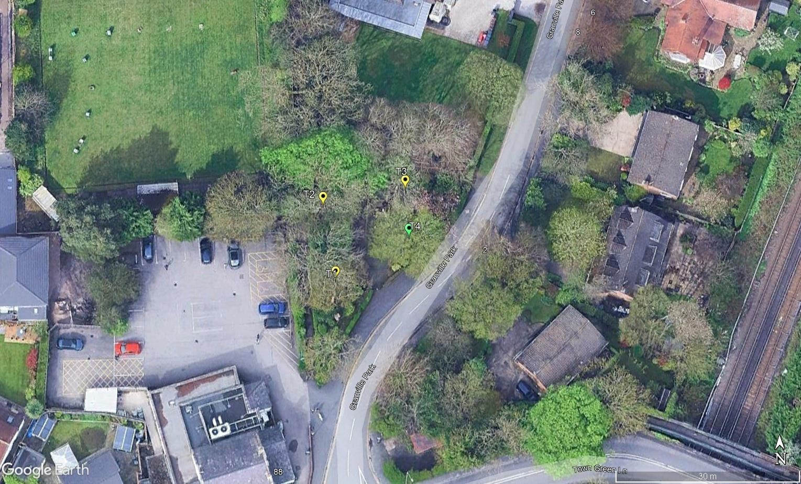
Site: Granville Park War Memorial,
Aughton, L39 5DS TREE
Job No. BTC3156 SURVEY
Scale: Not to Scale
Paper Size (for printing): A4 PLAN
Date: July 2025 (Granville Park War Memorial – Site One)

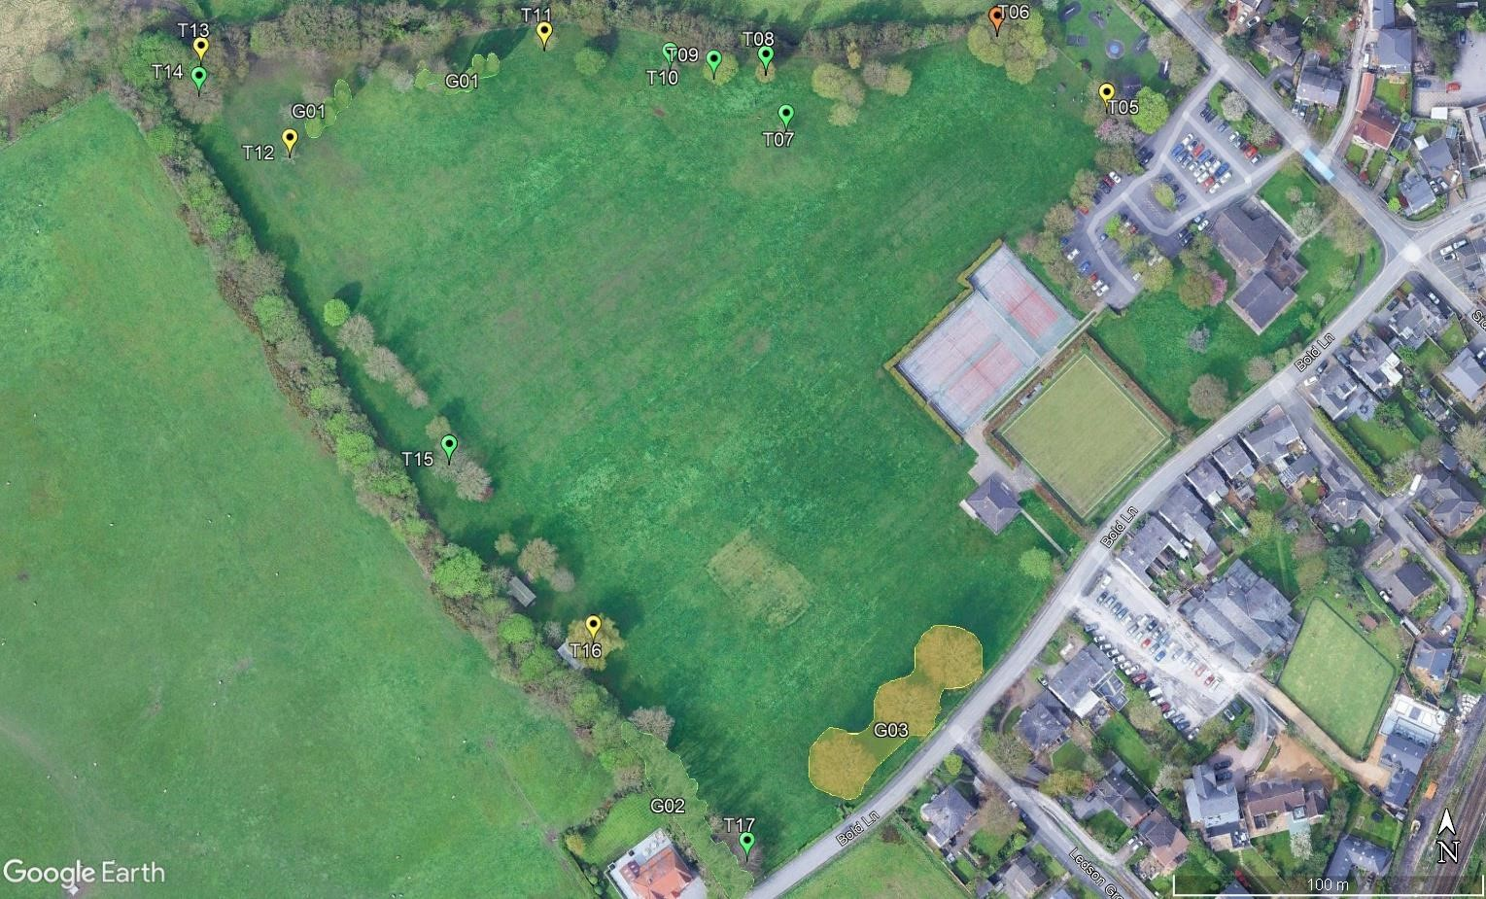

Site: William Arnold Silcock Memorial
T = Individual Tree | G = Group of Trees Playing Field, Aughton, L39 5DJ TREE
BTC3156  Not to  Size (for | SURVEY PLAN
July 2025 | (William Arnold Silcock Memorial Playing
Field – Site Two)
T = Individual Tree | G = Group of Trees | Site: Rachel Taylor Memorial Playing Field and Play Area, off Delph Park Avenue, Aughton L39 5DE. | TREE
 | Job No. BTC3156 Scale: Not to Scale | SURVEY PLAN
 | Paper Size (for printing): A4
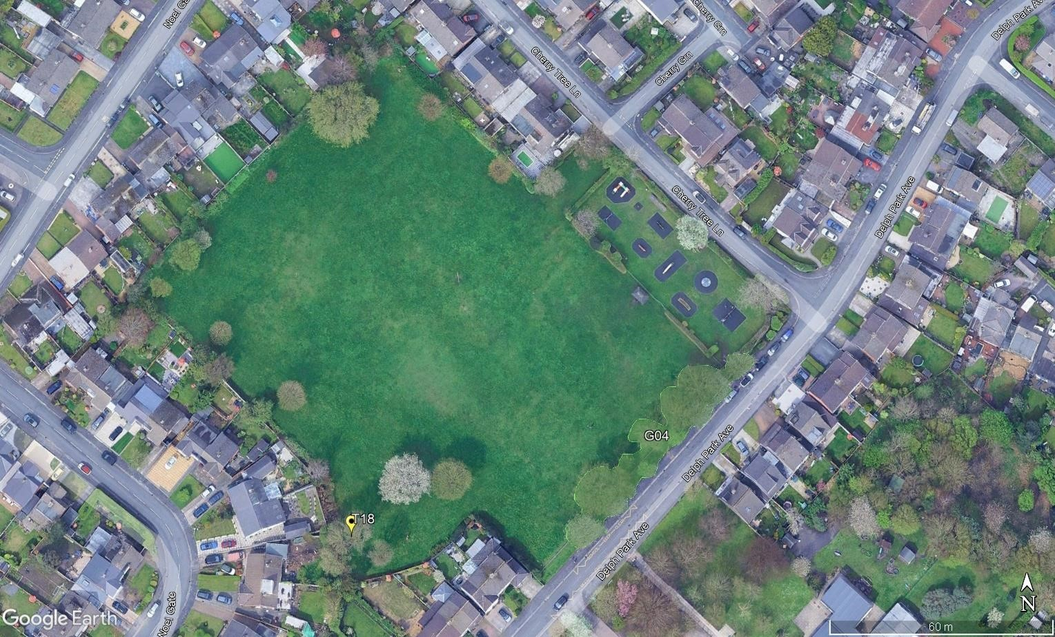

(Rachel Taylor Memorial Playing Field and
Date: July 2025 Play Area – Site 3)
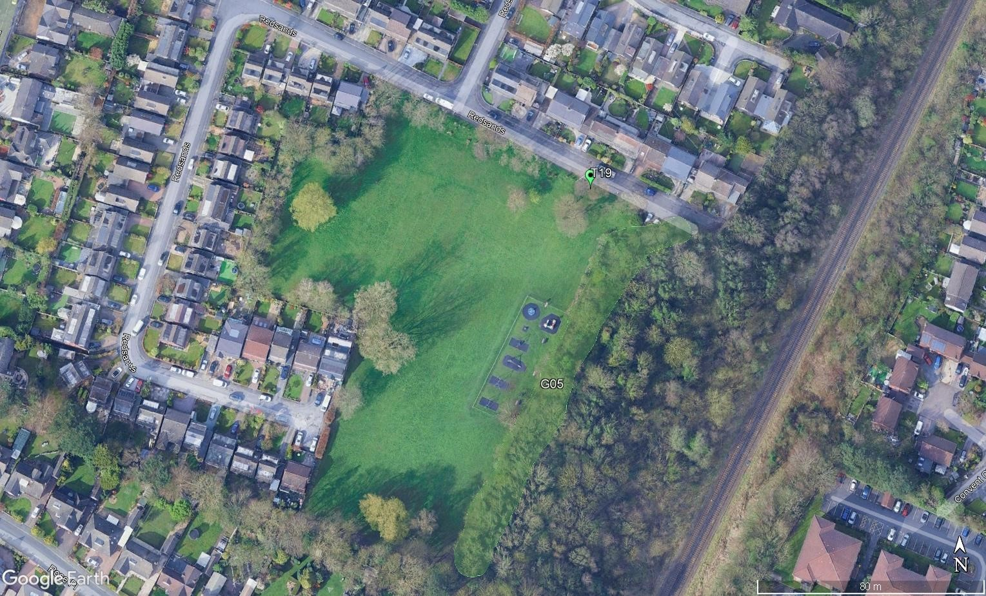

Site: Redsands Park and Play Area, off
T = Individual Tree | G = Group of Trees Prescot Road, Aughton L39 4SQ TREE
BTC3156  Not to  Size (for  July 2025 | SURVEY  PLAN  (Redsands Park and Play Area – Site Four)

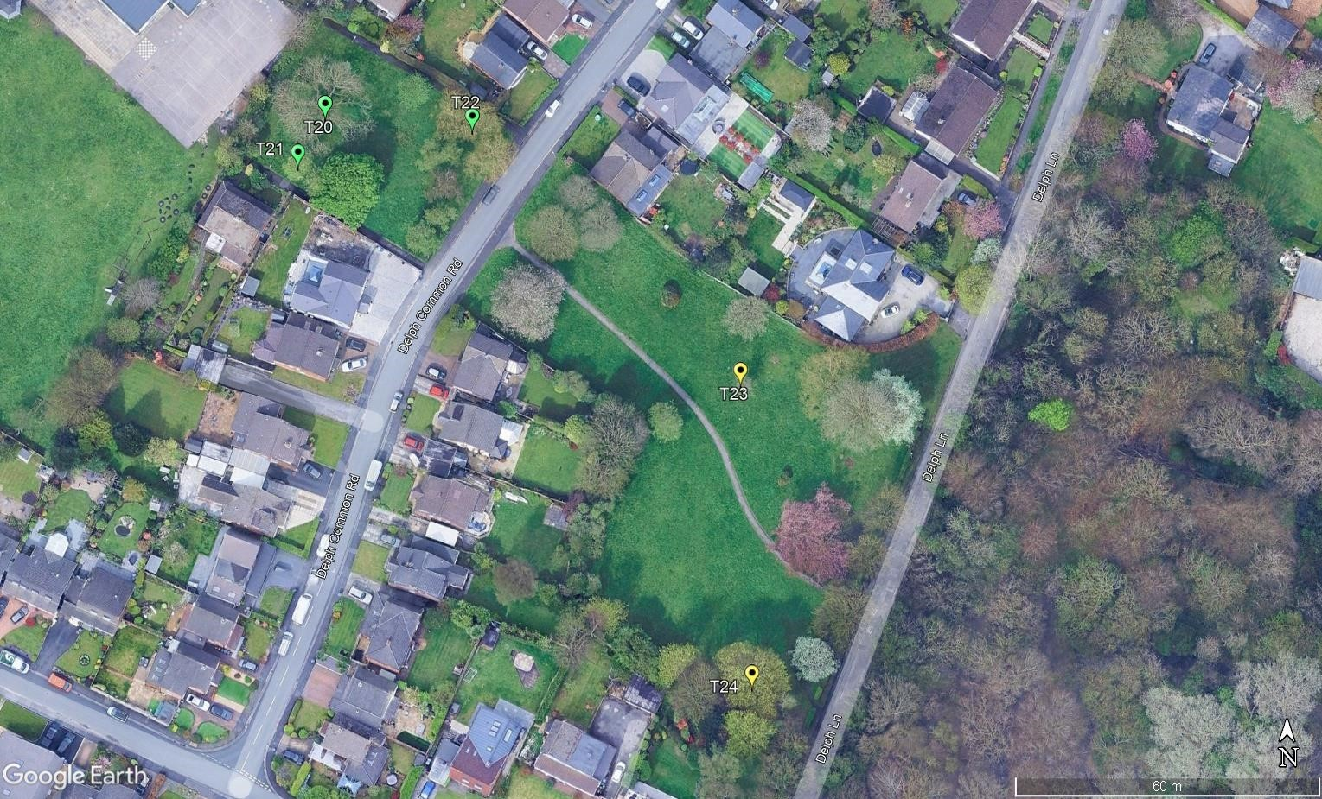
Site: The Common & The Precinct, off

T = Individual Tree with Risk of Harm of 1/1,000 or greater
with Risk of Harm between 1/1,000 and 1/10,000
with Risk of Harm between 1/10,000 and 1/1,000,000 with Risk of Harm less than 1/1,000,000
Delph Common Road, Aughton, L39 5DW TREE
BTC3156  Not to  Size (for  July 2025 | SURVEY  PLAN  (The Common & The Precinct – Site Five)

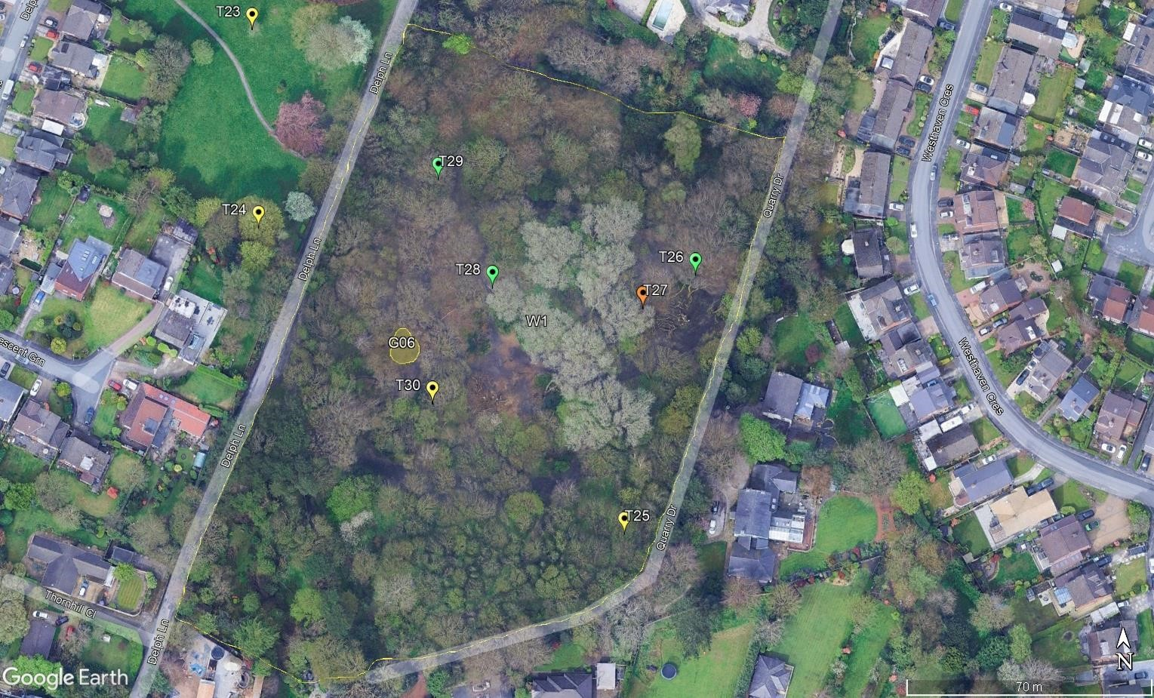

Site: Delph Quarry Woodland (“The
T = Individual Tree | G = Group of Trees | W = Woodland Delph”), off Delph Lane, Aughton L39 5EB TREE
/Group/Woodland with Risk of Harm of 1/1,000 or greater  /Group/Woodland with Risk of Harm between 1/1,000 and 1/10,000  /Group/Woodland with Risk of Harm between 1/10,000 and 1/1,000,000  /Group/Woodland with Risk of Harm less than 1/1,000,000 | BTC3156  Not to  Size (for  July 2025 | SURVEY PLAN  (Delph Quarry Woodland – Site Six)

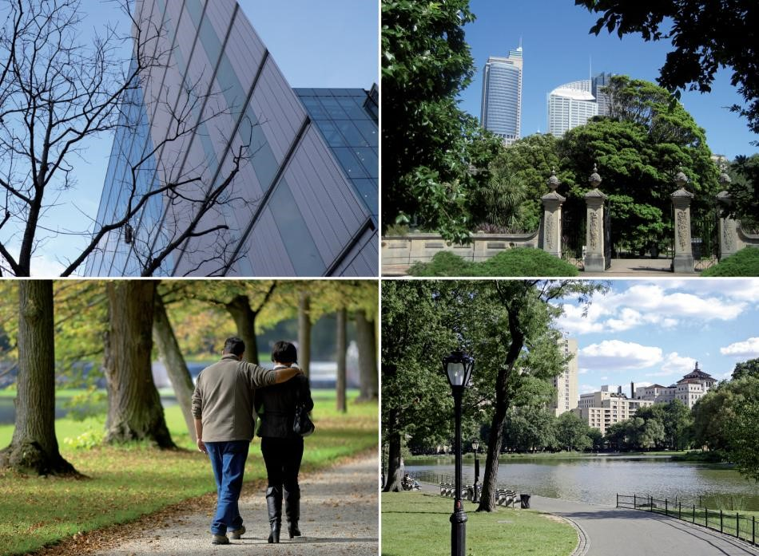



Quantified Tree Risk Assessment Practice Note
"When you can measure what you are speaking about, and express it in numbers, you know something about it; but when you cannot measure it, when you cannot express it in numbers, your knowledge is of a meagre and unsatisfactory kind”
William Thomson, Lord Kelvin, Popular Lectures and Addresses [1891-1894]

1. INTRODUCTION
Every day we encounter risks in all of our activities, and the way we manage those risks is to make choices. We weigh up the costs and benefits of the risk to determine whether it is acceptable, unacceptable, or tolerable. For example, if you want to travel by car you must accept that even with all the extensive risk control measures, such as seat-belts, speed limits, airbags, and crash barriers, there is still a significant risk of death. This is an everyday risk that is taken for granted and tolerated by millions of people in return for the benefits of convenient travel. Managing trees should take a similarly balanced approach.
A risk from falling trees exists only if there is both potential for tree failure and potential for harm to result. The job of the risk assessor is to consider the likelihood and consequences of tree failure. The outcome of this assessment can then inform consideration of the risk by the tree manager, who may also be the owner.
Using a comprehensive range of values, Quantified Tree Risk Assessment (QTRA) enables the tree assessor to identify and analyse the risk from tree failure in three key stages. 1) to consider land-use in terms of vulnerability to impact and likelihood of occupation, 2) to consider the consequences of an impact, taking account of the size of the tree or branch concerned, and 3) to estimate the probability that the tree or branch will fail onto the land-use in question. Estimating the values of these components, the assessor can use the QTRA manual calculator or software application to calculate an annual Risk of Harm from a particular tree. To inform management decisions, the risks from different hazards can then be both ranked and compared, and considered against broadly acceptable and tolerable levels of risk.
A Proportionate Approach to Risks from Trees The risks from falling trees are usually very low and high risks will usually be encountered only in areas with either high levels of human occupation or with valuable property. Where levels of human occupation and value of property are sufficiently low, the assessment of trees for structural weakness will not usually be necessary. Even when land-use indicates that the assessment of trees is appropriate, it is seldom proportionate to assess and evaluate the risk for each individual tree in a population. Often, all that is required is a brief consideration of the trees to identify gross signs of structural weakness or declining health. Doing all that is reasonably practicable does not mean that all trees have to be individually examined on a regular basis (HSE 2013).
The QTRA method enables a range of approaches from the broad assessment of large collections of trees to, where necessary, the detailed assessment of an individual tree.

Risk of Harm
The QTRA output is termed the Risk of Harm and is a combined measure of the likelihood and consequences of tree failure, considered against the baseline of a lost human life within the coming year.

ALARP (As Low As Reasonably Practicable)
Determining that risks have been reduced to As Low As Reasonably Practicable (HSE 2001) involves an evaluation of both the risk and the sacrifice or cost involved in reducing that risk. If it can be demonstrated that there is gross disproportion between them, the risk being insignificant in relation to the sacrifice or cost, then to reduce the risk further is not ‘reasonably practicable’.

Costs and Benefits of Risk Control
Trees confer many benefits to people and the wider environment. When managing any risk, it is essential to maintain a balance between the costs and benefits of risk reduction, which should be considered in the determination of ALARP. It is not only the financial cost of controlling the risk that should be considered, but also the loss of tree-related benefits, and the risk to workers and the public from the risk control measure itself.
When considering risks from falling trees, the cost of risk control will usually be too high when it is clearly ‘disproportionate’ to the reduction in risk. In the context of QTRA, the issue of ‘gross disproportion’, where decisions are heavily biased in favour of safety, is only likely to be considered where there are risks of 1/10,000 or greater.

Acceptable and Tolerable Risks
The Tolerability of Risk framework (ToR) (HSE 2001) is a widely accepted approach to reaching decisions on whether risks are broadly acceptable, unacceptable, or tolerable. Graphically represented in Figure 1, ToR can be summarised as having a Broadly Acceptable Region where the upper limit is an annual risk of death 1/1,000,000, an Unacceptable Region for which the lower limit is 1/1,000, and between these a Tolerable Region within which the tolerability of a risk will be dependent upon the costs and benefits of risk reduction. In the Tolerable Region, we must ask whether the benefits of risk control are sufficient to justify their cost.
In respect of trees, some risks cross the Broadly Acceptable 1/1,000,000 boundary, but remain tolerable. This is because any further reduction would involve a disproportionate cost in terms of the lost environmental, visual, and other benefits, in addition to the financial cost of controlling the risk.
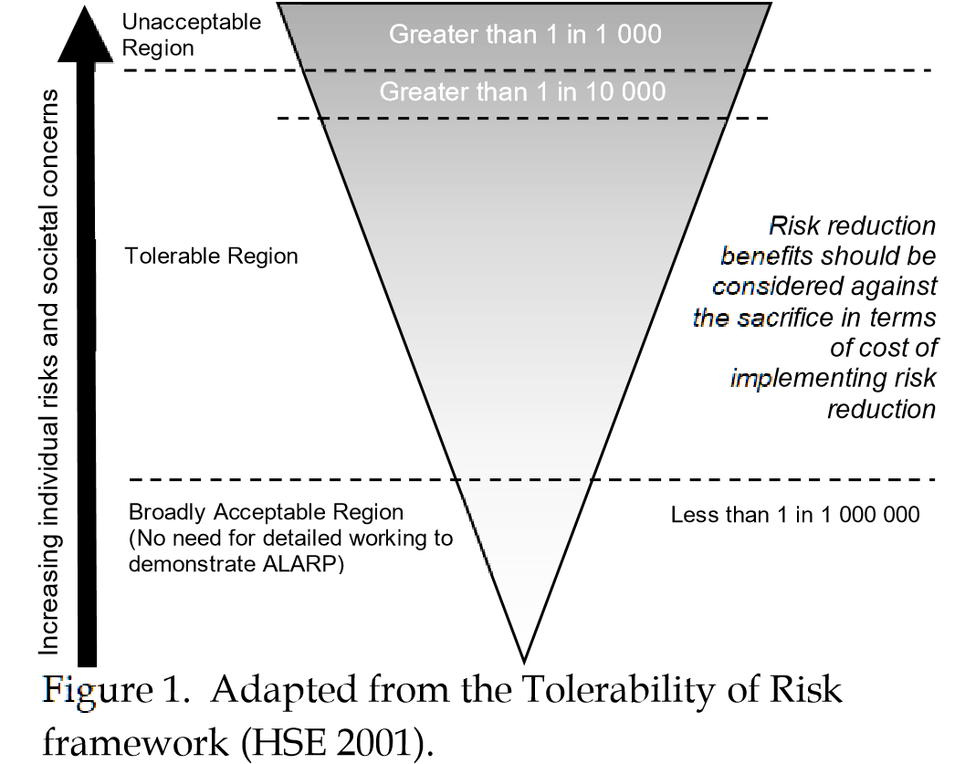

Value of Statistical Life
The Value of Statistical Life (VOSL), is a widely applied risk management device, which uses the value of a hypothetical life to guide the proportionate allocation of resources to risk reduction. In the UK, this value is currently in the region of £2,000,000, and this is the value adopted in the QTRA method.
In QTRA, placing a statistical value on a human life has two particular uses. Firstly, QTRA uses VOSL to enable damage to property to be compared with the loss of life, allowing the comparison of risks to people and property. Secondly, the proportionate allocation of financial resources to risk reduction can be informed by VOSL. “A value of statistical life of £1,000,000 is just another way of saying that a reduction in risk of death of 1/100,000 per year has a value of £10 per year” (HSE 1996).
Internationally, there is variation in VOSL, but to provide consistency in QTRA outputs, it is suggested that VOSL of £2,000,000 should be applied internationally. This is ultimately a decision for the tree manager.

2. OWNERSHIP OF RISK
Where many people are exposed to a risk, it is shared between them. Where only one person is exposed, that individual is the recipient of all of the risk and if they have control over it, they are also the owner of the risk. An individual may choose to accept or reject any particular risk to themselves, when that risk is under their control. When risks that are imposed upon others become elevated, societal concern will usually require risk controls, which ultimately are imposed by the courts or government regulators.
Although QTRA outputs might occasionally relate to an individual recipient, this is seldom the case. More often, calculation of the Risk of Harm is based on a cumulative occupation – i.e. the number of people per hour or vehicles per day, without attempting to identify the individuals who share the risk.
Where the risk of harm relates to a specific individual or a known group of people, the risk manager might consider the views of those who are exposed to the risk when making management decisions. Where a risk is imposed on the wider community, the principles set out in the ToR framework can be used as a reasonable approach to determine whether the risk is ALARP.

3. THE QTRA METHOD - VERSION 5
The input values for the three components of the QTRA calculation are set out in broad ranges of Target, Size, and Probability of Failure. The assessor estimates values for these three components and inputs them on either the manual calculator or software application to calculate the Risk of Harm.

Assessing Land-use (Targets)
The nature of the land-use beneath or adjacent to a tree will usually inform the level and extent of risk assessment to be carried out. In the assessment of Targets, six ranges of value are available. Table 2 sets out these ranges for vehicular frequency, human occupation and the monetary value of damage to property.

Human Occupation
The probability of pedestrian occupation at a particular location is calculated on the basis that an average pedestrian will spend five seconds walking beneath an average tree. For example, an average occupation of ten pedestrians per day, each occupying the Target for five seconds is a daily occupation of fifty seconds, giving a likelihood of occupation 1/1,728. Where a longer occupation is likely, as with a habitable building, outdoor café, or park bench, the period of occupation can be measured, or estimated as a proportion of a given unit of time, e.g. six hours per day (1/4). The Target is recorded as a range (Table 2).

Weather Affected Targets
Often the nature of a structural weakness in a tree is such that the probability of failure is greatest during windy weather, while the probability of the site being occupied by people during such weather is often low. This applies particularly to outdoor recreational areas. When estimating human Targets, the risk assessor must answer the question ‘in the weather conditions that I expect the likelihood of failure of the tree to be initiated, what is my estimate of human occupation?’ Taking this approach, rather than using the average occupation, ensures that the assessor considers the relationship between weather, people, and trees, along with the nature of the average person with their ability to recognise and avoid unnecessary risks.

Vehicles on the Highway
In the case of vehicles, likelihood of occupation may relate to either the falling tree or branch striking the vehicle or the vehicle striking the fallen tree. Both types of impact are influenced by vehicle speed; the faster the vehicle travels the less likely it is to be struck by the falling tree, but the more likely it is to strike a fallen tree. The probability of a vehicle occupying any particular point in the road is the ratio of the time it is occupied - including a safe stopping distance - to the total time. The average vehicle on a UK road is occupied by 1.6 people (DfT 2010). To account for the substantial protection that the average vehicle provides against most tree impacts and in particular, frontal collisions, QTRA values the substantially protected 1.6 occupants in addition to the value of the vehicle as equivalent to one exposed human life.

Property

Table 1. Size
Size Range | Size of tree or branch | Range of Probability
1 | > 450mm (>18”) dia. | 1/1 - >1/2
2 | 260mm (10¹/₂”) dia. - 450mm (18”) dia. | 1/2 - >1/8.6
3 | 110mm (4¹/₂”) dia. - 250mm (10”) dia. | 1/8.6 - >1/82
4 | 25mm (1”) dia. - 100mm (4”) dia. | 1/82 - 1/2 500
* Range 1 is based on a diameter of 600mm.
Property can be anything that could be damaged by a falling tree, from a dwelling, to livestock, parked car, or fence. When evaluating the exposure of property to tree failure, the QTRA assessment considers the cost of repair or replacement that might result from failure of the tree. Ranges of value are presented in Table 2 and the assessor’s estimate need only be sufficient to determine which of the six ranges the cost to select.
In Table 2, the ranges of property value are based on a VOSL of £2,000,000, e.g. where a building with a replacement cost of £20,000 would be valued at 0.01 (1/100) of a life (Target Range 2).
When assessing risks in relation to buildings, the Target to be considered might be the building, the occupants, or both. Occupants of a building could be protected from harm by the structure or substantially exposed to the impact from a falling tree if the structure is not sufficiently robust, and this will determine how the assessor categorises the Target.

Multiple Targets
A Target might be constantly occupied by more than one person and QTRA can account for this. For example, if it is projected that the average occupation will be constant by 10 people, the Risk of Harm is calculated in relation to one person constantly occupying the Target before going on to identify that the average occupation is 10 people. This is expressed as Target 1(10T)/1, where 10T represents the Multiple Targets. In respect of property, a Risk of Harm 1(10T)/1 would be equivalent to a risk of losing £20,000,000 as opposed to £2,000,000.

Tree or Branch Size
A small dead branch of less than 25mm diameter is not likely to cause significant harm even in the case of direct contact with a Target, while a falling branch with a diameter greater than 450mm is likely to cause some harm in the event of contact with all but the most robust Target. The QTRA method categorises
Size by the diameter of tree stems and branches (measured beyond any basal taper). An equation derived from weight measurements of trees of different stem diameters is used to produce a data set of comparative weights of trees and branches ranging from 25mm to 600mm diameter, from which Table 1 is compiled. The size of dead branches might be discounted where they have undergone a significant reduction in weight because of degradation and shedding of subordinate branches. This discounting, referred to as ‘Reduced Mass’, reflects an estimated reduction in the mass of a dead branch.
Target Range | Property  (repair or replacement cost) | Human  ( not in vehicles) |  | Vehicle Traffic (number per day) | Ranges of Value  (probability of occupation or fraction of £2 000,000)
1 | £2 000,000 – >£200,000 | Occupation:  Pedestrians & cyclists: | Constant – 2.5 hours/day  720/hour – 73/hour | 26 000 – 2 700 @ 110kph (68mph)  32,000 – 3 300 @ 80kph (50mph)  47 000 – 4 800 @ 50kph (32mph) | 1/1 – >1/10
2 | £200,000 – >£20 000 | Occupation: 2.4 hours/day – 15 min/day  Pedestrians 72/hour – 8/hour & cyclists: |  | - 600 – 270 @ 110kph (68mph)  - 200 – 330 @ 80kph (50mph)  - 700 – 480 @ 50kph (32mph) | 1/10 – >1/100
3 | £20 000 – >£2 000 | Occupation:  Pedestrians & cyclists: | 14 min/day – 2 min/day  7/hour – 2/hour | 260 – 27 @ 110kph (68mph)  320 – 33 @ 80kph (50mph)  470 – 48 @ 50kph (32mph) | 1/100 – >1/1,000
4 | £2 000 – >£200 | Occupation: 1 min/day – 2 min/week  Pedestrians 1/hour – 3/day & cyclists: |  | 26 – 4 @ 110kph (68mph)  32 – 4 @ 80kph (50mph)  47 – 6 @ 50kph (32mph) | 1/1,000 – >1/10,000
5 | £200 – >£20 | Occupation:  Pedestrians & cyclists: | 1 min/week – 1 min/month  2/day – 2/week | 3 – 1 @ 110kph (68mph)  3 – 1 @ 80kph (50mph)  5 – 1 @ 50kph (32mph) | 1/10,000 – >1/100,000
6 | £20 – £2 | Occupation: <1 min/month – 0.5 min/year  Pedestrians 1/week – 6/year & cyclists: |  | None | 1/100,000 – 1/1,000,000
Table 2. Targets
Vehicle, pedestrian and property Targets are categorised by their frequency of use or their monetary value. The probability of a vehicle or pedestrian occupying a Target area in Target Range 4 is between the upper and lower limits of 1/1,000 and >1/10,000 (column 5). Using the VOSL £2 000,000, the property repair or

replacement value for Target Range 4 is £2 000 - >200.

Probability of Failure
In the QTRA assessment, the probability of tree or branch failure within the coming year is estimated and recorded as a range of value (Ranges 1 – 7, Table 3).
Selecting a Probability of Failure (PoF) Range requires the assessor to compare their assessment of the tree or branch against a benchmark of either a noncompromised tree at Probability of Failure Range 7, or a tree or branch that we expect to fail within the year, which can be described as having a 1/1 probability of failure.
During QTRA training, Registered Users go through a number of field exercises in order to calibrate their estimates of Probability of Failure.

Table 3. Probability of Failure

Probability of Failure Range | Probability
1 | 1/1 - >1/10
2 | 1/10 - >1/100
3 | 1/100 - >1/1,000
4 | 1/1,000 - >1/10,000
5 | 1/10,000 – >1/100,000
6 | 1/100,000 – >1/1,000,000
7 | 1/1,000,000 – 1/10,000,000
The probability that the tree or branch will fail within the coming year.

The QTRA Calculation
The assessor selects a Range of values for each of the three input components of Target, Size and Probability of Failure. The Ranges are entered on either the manual calculator or software application to calculate a Risk of Harm.
The Risk of Harm is expressed as a probability and is rounded, to one significant figure. Any Risk of Harm that is lower than 1/1,000,000 is represented as <1/1,000,000. As a visual aid, the Risk of Harm is colour coded using the traffic light system illustrated in Table 4 (page 7).

Risk of Harm - Monte Carlo Simulations
The Risk of Harm for all combinations of Target, Size and Probability of Failure Ranges has been calculated using Monte Carlo simulations. The QTRA Risk of Harm is the mean value from each set of Monte Carlo results.
In QTRA Version 5, the Risk of Harm should not be calculated without the manual calculator or software application.
Assessing Groups and Populations of Trees When assessing populations or groups of trees, the highest risk in the group is quantified and if that risk is tolerable, it follows that risks from the remaining trees will also be tolerable, and further calculations are unnecessary. Where the risk is intolerable, the next highest risk will be quantified, and so on until a tolerable risk is established. This process requires prior knowledge of the tree manager’s risk tolerance.

Accuracy of Outputs
The purpose of QTRA is not necessarily to provide high degrees of accuracy, but to provide for the quantification of risks from falling trees in a way that risks are categorised within broad ranges (Table 4).

4. INFORMING MANAGEMENT DECISIONS
Balancing Costs and Benefits of Risk Control When controlling risks from falling trees, the benefit of reduced risk is obvious, but the costs of risk control are all too often neglected. For every risk reduced there will be costs, and the most obvious of these is the financial cost of implementing the control measure. Frequently overlooked is the transfer of risks to workers and the public who might be directly affected by the removal or pruning of trees. Perhaps more importantly, most trees confer benefits, the loss of which should be considered as a cost when balancing the costs and benefits of risk control.
When balancing risk management decisions using QTRA, consideration of the benefits from trees will usually be of a very general nature and not require detailed consideration. The tree manager can consider, in simple terms, whether the overall cost of risk control is a proportionate one. Where risks are

approaching 1/10,000, this may be a straightforward balancing of cost and benefits. Where risks are 1/10,000 or greater, it will usually be appropriate to implement risk controls unless the costs are grossly disproportionate to the benefits rather than simply disproportionate. In other words, the balance being weighted more on the side of risk control with higher associated costs.

Considering the Value of Trees
It is necessary to consider the benefits provided by trees, but they cannot easily be monetised and it is often difficult to place a value on those attributes such as habitat, shading and visual amenity that might be lost to risk control.
A simple approach to considering the value of a tree asset is suggested here, using the concept of ‘average benefits’. When considered against other similar trees, a tree providing ‘average benefits’ will usually present a range of benefits that are typical for the species, age and situation. Viewed in this way, a tree providing ‘average benefits’ might appear to be low when compared with particularly important trees – such as in Figure 2, but should nonetheless be sufficient to offset a Risk of Harm of less than 1/10,000. Without having to consider the benefits of risk controls, we might reasonably assume that below 1/10,000, the risk from a tree that provides ‘average benefits’ is ALARP.
In contrast, if it can be said that the tree provides lower than average benefits because, for example, it is declining and in poor physiological condition, it may be necessary to consider two further elements. Firstly, is the Risk of Harm in the upper part of the Tolerable Region, and secondly, is the Risk of Harm likely to increase before the next review because of an increased Probability of Failure. If both these conditions apply then it might be appropriate to consider the balance of costs and benefits of risk reduction in order to determine whether the risk is ALARP. This balance requires the tree manager to take a view of both the reduction in risk and the costs of that reduction.
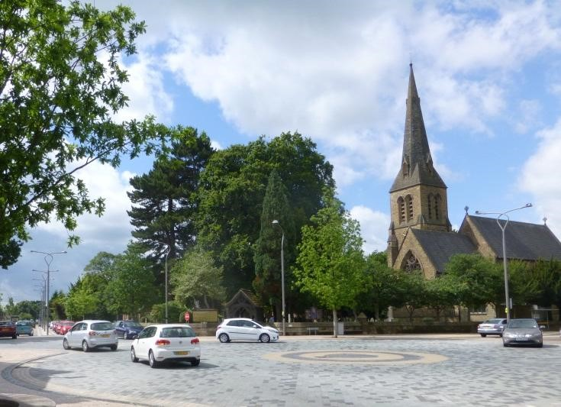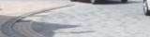
Fig. 2

Lower Than Average Benefits from Trees
Usually, the benefits provided by a tree will only be significantly reduced below the ‘average benefits’ that are typical for the species, age and situation, if the life of the benefits is likely to be shortened, perhaps because the tree is declining or dead. That is not to say that a disbenefit, such as undesirable shading, lifting of a footpath, or restricting the growth of other trees, should not also be considered in the balance of costs and benefits.
The horse chestnut tree in Figure 3 has recently died, and over the next few years, may provide valuable habitats. However, for this tree species and the relatively fast rate at which its wood decays, the lifetime of these benefits is likely to be limited to only a few years. This tree has an already reduced value that will continue to reduce rapidly over the coming five to ten years at the same time as the Risk of Harm is expected to increase. There will be changes in the benefits provided by the tree as it degrades. Visual qualities are likely to reduce while the decaying wood provides habitats for a range of species, for a short while at least. There are no hard and fast measures of these benefits and it is for the tree manager to decide what is locally important and how it might be balanced with the risks.
Where a risk is within the Tolerable Region and the tree confers lower than average benefits, it might be appropriate to consider implementing risk control while taking account of the financial cost. Here, VOSL can be used to inform a decision on whether the cost of risk control is proportionate. Example 3 below puts this evaluation into a tree management context.
There will be occasions when a tree is of such minimal value and the monetary cost of risk reduction so low that it might be reasonable to further reduce an already relatively low risk. Conversely, a tree might be of such considerable value that an annual risk of death greater than 1/10,000 would be deemed tolerable.
Occasionally, decisions will be made to retain elevated risks because the benefits from the tree are particularly high or important to stakeholders, and in these situations, it might be appropriate to assess and document the benefits in some detail. If detailed assessment of benefits is required, there are several methodologies and sources of information (Forest Research 2010).

Delegating Risk Management Decisions
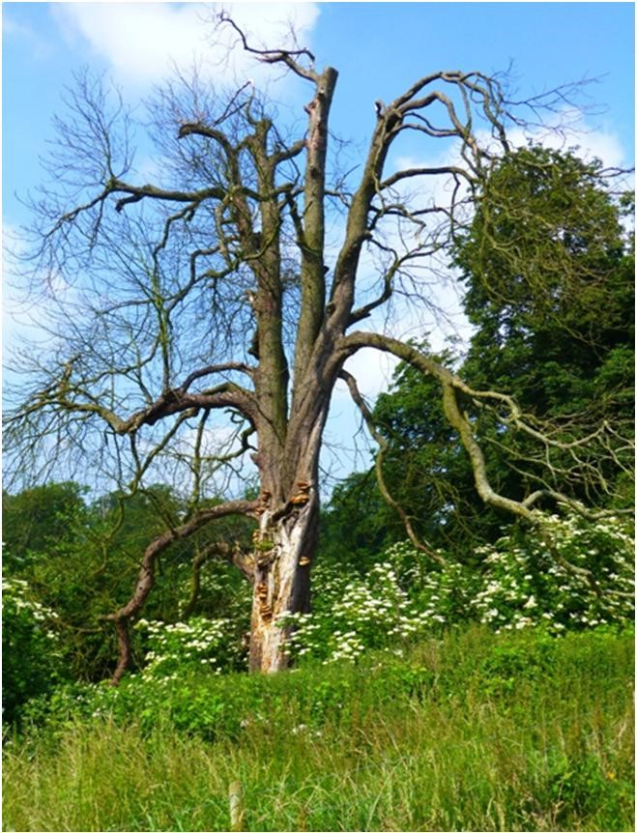
Fig. 3
Understanding of the costs with which risk reduction is balanced can be informed by the risk assessor’s knowledge, experience and on-site observations, but the risk management decisions should be made by the tree manager. That is not to say that the tree manager should review and agree every risk control measure, but when delegating decisions to surveyors and other staff or advisors, tree managers should set out in a policy, statement or contract, the principles and perhaps thresholds to which trees and their associated risks will ordinarily be managed.
Based on the tree manager accepting the principles set out in the QTRA Practice Note and or any other specific instructions, the risk assessor can take account of the cost/benefit balance and for most situations will be able to determine whether the risk is ALARP when providing management recommendations.
Table 4. QTRA Advisory Risk Thresholds
Thresholds Description Action

Unacceptable

Risks will not ordinarily be • Control the risk

tolerated
1/1,000

Unacceptable
(where imposed on others) • Control the risk
Risks will not ordinarily be • Review the risk

tolerated

Tolerable
(by agreement) • Control the risk unless there is

Risks may be tolerated if broad stakeholder agreement to
those exposed to the risk tolerate it, or the tree has

accept it, or the tree has exceptional value exceptional value • Review the risk
1/10,000

Tolerable

(where imposed on others) • Assess costs and benefits of risk
Risks are tolerable if control

ALARP • Control the risk only where a significant benefit might be
achieved at reasonable cost

• Review the risk
1/1,000,000

Broadly Acceptable
Risk is already ALARP • No action currently required
• Review the risk

QTRA Informative Risk Thresholds
The QTRA advisory thresholds in Table 4 are proposed as a reasonable approach to balancing safety from falling trees with the costs of risk reduction. This approach takes account of the widely applied principles of ALARP and ToR, but does not dictate how these principles should be applied. While the thresholds can be the foundation of a robust policy for tree risk management, tree managers should make decisions based on their own situation, values and resources. Importantly, to enable tree assessors to provide appropriate management guidance, it is helpful for them to have some understanding of the tree owner’s management preferences prior to assessing the trees.
A Risk of Harm that is less than 1/1,000,000 is Broadly Acceptable and is already ALARP. A Risk of Harm 1/1,000 or greater is unacceptable and will not ordinarily be tolerated. Between these two values, the Risk of Harm is in the Tolerable Region of ToR and will be tolerable if it is ALARP. In the Tolerable Region, management decisions are informed by consideration of the costs and benefits of risk control, including the nature and extent of those benefits provided by trees, which would be lost to risk control measures.
For the purpose of managing risks from falling trees, the Tolerable Region can be further broken down into two sections. From 1/1,000,000 to less than 1/10,000, the Risk of Harm will usually be tolerable providing that the tree confers ‘average benefits’ as discussed above. As the Risk of Harm approaches 1/10,000 it will be necessary for the tree manager to consider in more detail the benefits provided by the tree and the overall cost of mitigating the risk.
A Risk of Harm in the Tolerable Region but 1/10,000 or greater will not usually be tolerable where it is imposed on others, such as the public, and if retained, will require a more detailed consideration of ALARP. In exceptional circumstances a tree owner might choose to retain a Risk of Harm that is 1/10,000 or greater. Such a decision might be based on the agreement of those who are exposed to the risk, or perhaps that the tree is of great importance. In these circumstances, the prudent tree manager will consult with the appropriate stakeholders whenever possible.

5. EXAMPLE QTRA CALCULATIONS AND RISK MANAGEMENT DECISIONS
Below are three examples of QTRA calculations and application of the QTRA Advisory Thresholds.
Example 1.
Target Size Probability of Failure Risk of Harm
<1/1,000,000
Range 6 x 1 x 3 =
Example 1 is the assessment of a large (Size 1), unstable tree with a probability of failure of between 1/100 and >1/1,000 (PoF 3). The Target is a footpath with less than one pedestrian passing the tree each week (Target 6). The Risk of Harm is calculated as less than 1/1,000,000 (green). This is an example of where the Target is so low consideration of the structural condition of even a large tree would not usually be necessary.

Example 2.
Target Size Probability of Failure Risk of Harm
1(2T)/50,000
Range 1 x 4 x 3 =
In Example 2, a recently dead branch (Size 4) overhangs a busy urban high street that is on average occupied constantly by two people, and here Multiple Target occupation is considered.
Having an average occupancy of two people, the Risk of Harm 1(2T)/50,000 (yellow) represents a twofold increase in the magnitude of the consequence and is therefore equivalent to a Risk of Harm 1/20,000 (yellow). This risk does not exceed 1/10,000, but being a dead branch at the upper end of the Tolerable Region it is appropriate to consider the balance of costs and benefits of risk control. Dead branches can be expected to degrade over time with the probability of failure increasing as a result. Because it is dead, some of the usual benefits from the branch have been lost and it will be appropriate to consider whether the financial cost of risk control would be proportionate.

Example 3.
Target Size Probability of Failure Risk of Harm
1/500,000
Range 3 x 3 x 3 =
In Example 3, a 200mm diameter defective branch overhangs a country road along which travel between 470 and 48 vehicles each day at an average speed of 50kph (32mph) (Target Range 3). The branch is split and is assessed as having a probability of failure for the coming year of between 1/100 and 1/1,000 (PoF Range 3). The Risk of Harm is calculated as 1/500,000 (yellow) and it needs to be considered whether the risk is ALARP. The cost of removing the branch and reducing the risk to Broadly Acceptable (1/1,000,000) is estimated at £350. To establish whether this is a proportionate cost of risk control, the following equation is applied. £2,000,000 (VOSL) x 1/500,000 = £4 indicating that the projected cost of £350 would be disproportionate to the benefit. Taking account of the financial cost, risk transfer to arborists and passers-by, the cost could be described as being grossly disproportionate, even if accrued benefits over say ten years were taken into account.

References
DfT. 2000. Highway Economic Note N. 1. ‘Valuation
of Benefits of Prevention of Road Accidents and Casualties’. Department for Transport.
DfT. 2010. Department for Transport. Vehicles Factsheet. Department for Transport, London. pp.
4. Available for download at http://www.dft.gov.uk/statistics
Forest Research. 2010. Benefits of green infrastructure - Report by Forest Research. Forest Research, Farnham, Surrey. 42 pp.
HSE. 1996. Use of Risk Assessment Within Government
Departments. Report prepared by the
Interdepartmental Liaison Group on Risk Assessment. Health and Safety Executive. HSE Books, Sudbury, Suffolk. 48 pp.
HSE. 2001. Reducing Risks: Protecting People. Health and Safety Executive, [online]. Available for download at
http://www.hse.gov.uk/risk/theory/r2p2.pdf (accessed 05/11/2013).

HSE. 2013. Sector Information Minute - Management of the risk from falling trees or branches. Health & Safety Executive, Bootle, [online]. Available for download at http://www.hse.gov.uk/foi/internalops/sims/ag_f ood/010705.htm (accessed 05/11/2013).
ISO. 2009. ISO Guide 73. Risk Management Vocabulary. International Organization for Standardization. Geneva. 17 pp.
Tritton, L. M. and Hornbeck, J. W. 1982. Biomass
Equations for Major Tree Species. General Technical Report NE69. United States Department of Agriculture.

Revision 5.2.4. Monetary values for non-uk versions updated at 1st January 2019.

© 2019. Published by
Quantified Tree Risk Assessment Limited. 9 Lowe Street, Macclesfield, Cheshire, SK11 7NJ, United Kingdom.

1 See Tables 1, 2 & 3.
2 Discussed further on page 5.
See Tables 1, 2 & 3.
For further information on the Monte Carlo simulation method, refer to http://en.wikipedia.org/wiki/Monte_Carlo_method

